## Structural Design Patterns

### Definition

Structural design patterns are all to do with how classes and objects are put together to form larger structures. As these structures get bigger over time, they can often get more complex. So these patterns are ways of tackling that complexity and simplifying these structures.

Two classifications

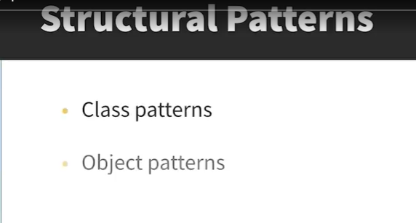

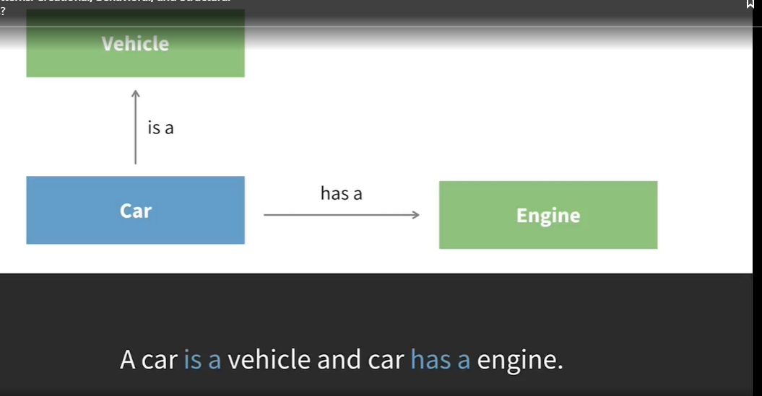

There are two different categories of structural design pattern. There are ones that focus on classes and ones that focus on objects. You can think of the difference between class patterns and object patterns as the difference between "is a" relationships and "has a" relationships.

#### Class Patterns

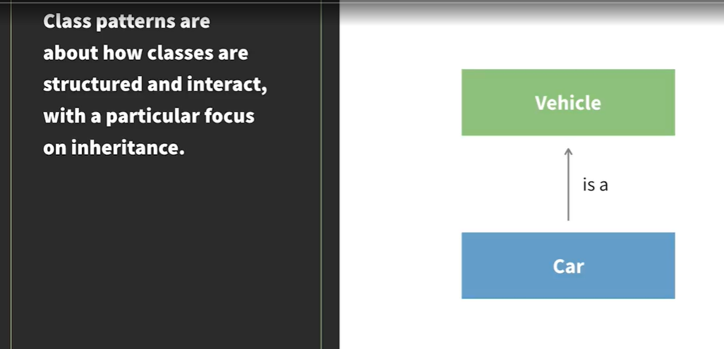

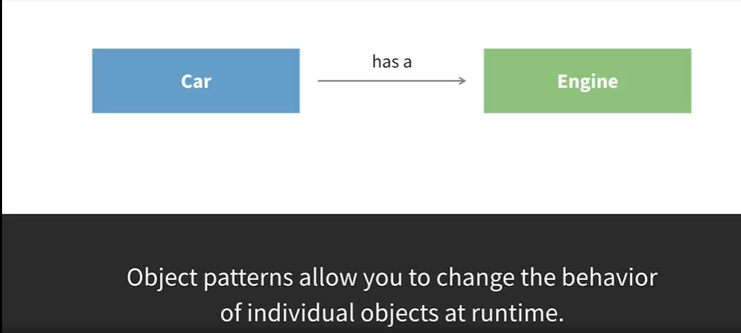

## Adapter Pattern

### Understand the Adapter Pattern

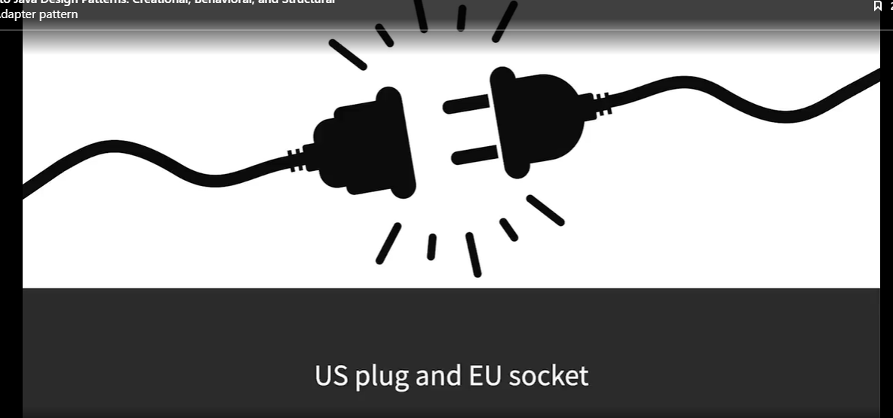

The adapter pattern allows classes to work together when they normally wouldn't be able to. Imagine a plug adapter. If you have a US plug and you travel to Europe, you can't put your plug straight in the socket. You need an adapter, and this allows the US plug and the European plug socket to work together.

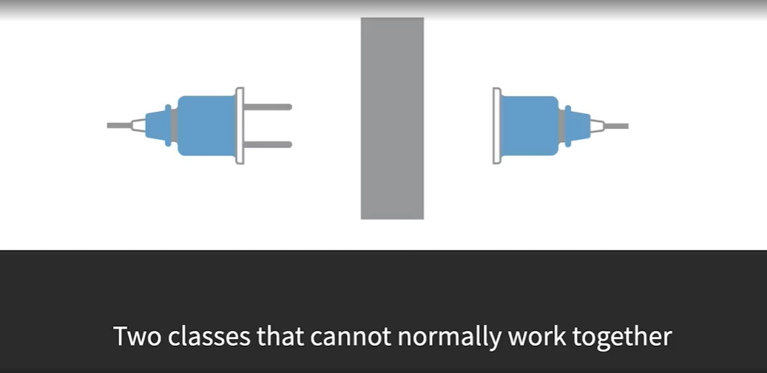

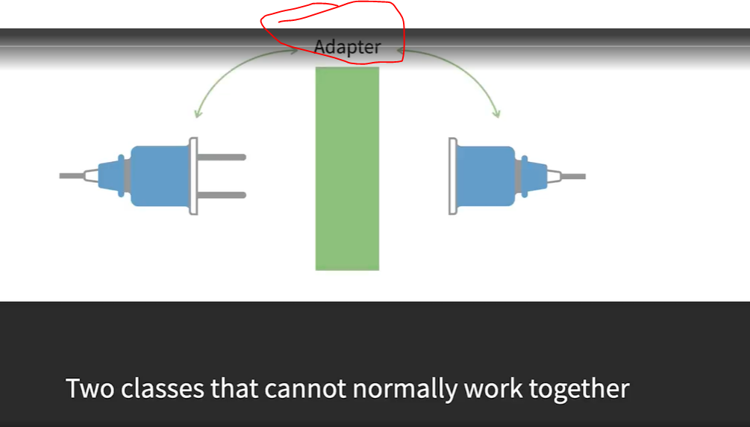

This is the concept that the adapter pattern is all about. You have two classes that can't normally work together because they have incompatible interfaces, and then you put an adapter in between them so that they can work together.

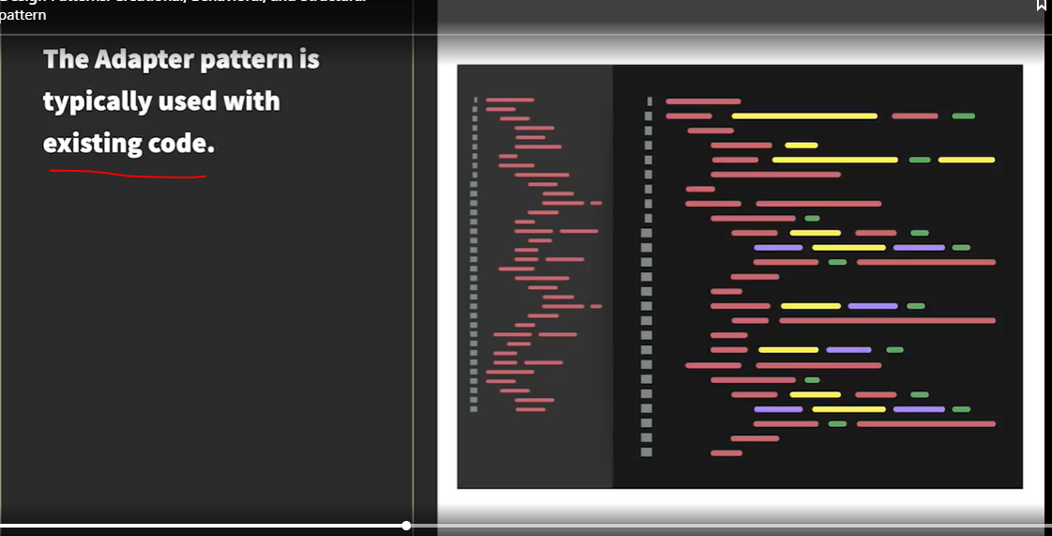

This is a pattern that's most often used when working with existing code, rather than writing new code. If you are writing something new, you just make sure that the classes you wanted to communicate would be able to. But if you're working with existing code and you can't or don't want to change it, the adaptive pattern can be a nice solution. One example is where you have a legacy code base and you need to add some new features to it. You might not want to change the existing code base because you don't want to risk breaking something, especially if there are no tests, or you might not even have access to it if it's in a third-party library.

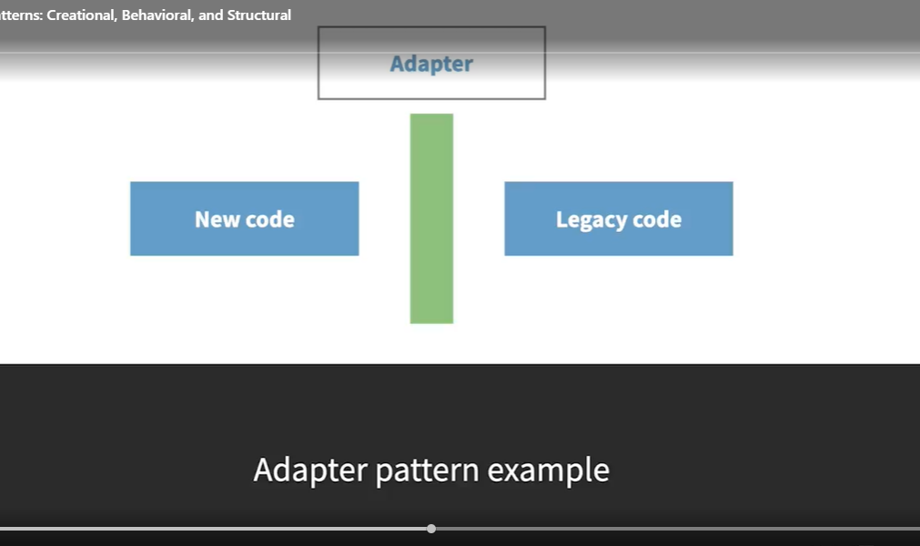

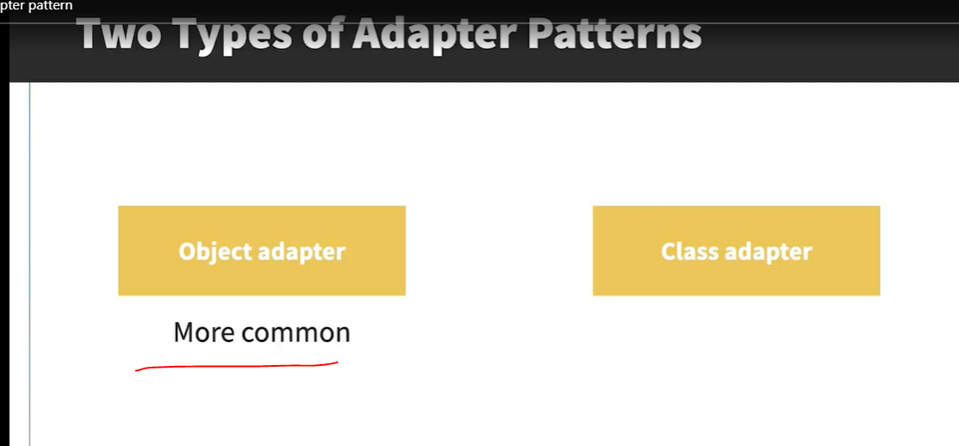

There are two different types of adaptive pattern; the class version and the object version. The object version is more common in Java because the class version relies on multiple inheritance. This isn't technically possible in Java, because you can't have classes that extend more than one other class, but a version of this can be achieved by using interfaces.

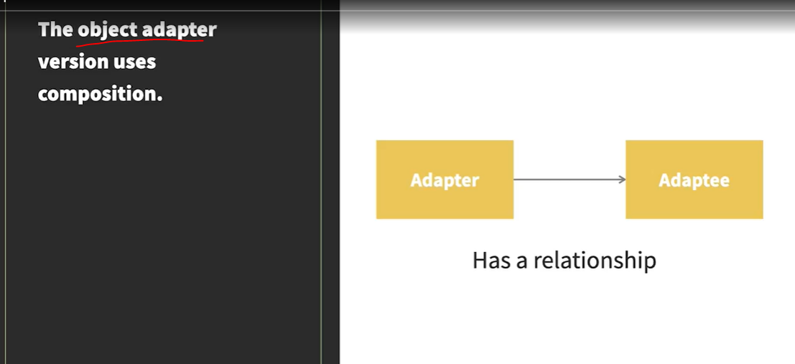

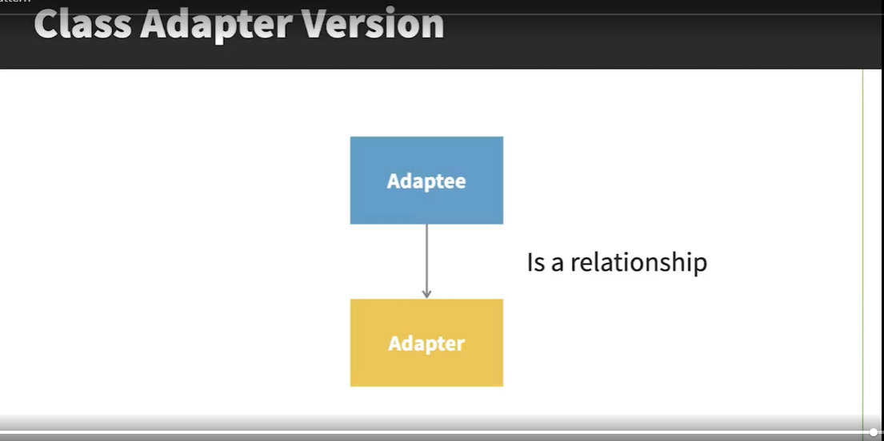

### Implement the Object Adapter Pattern

See Code below:

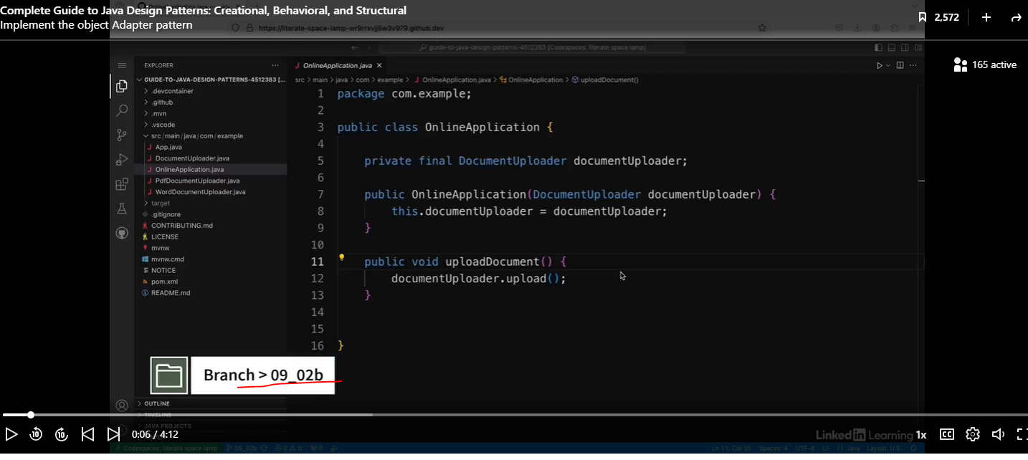

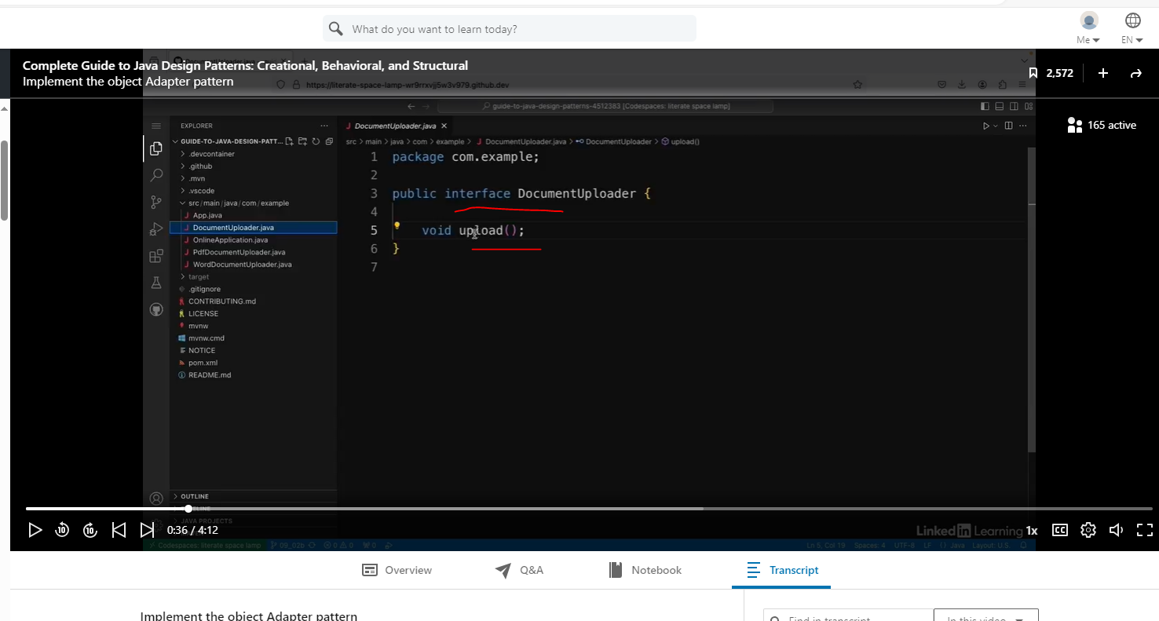

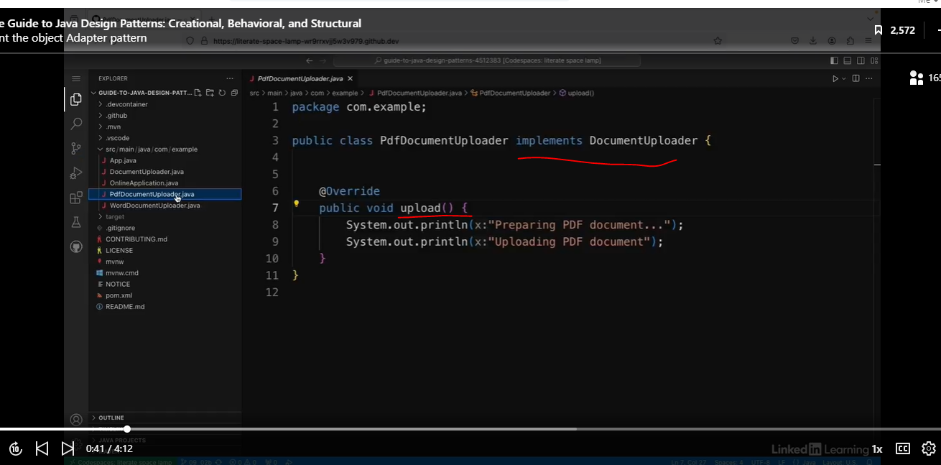

Client code.

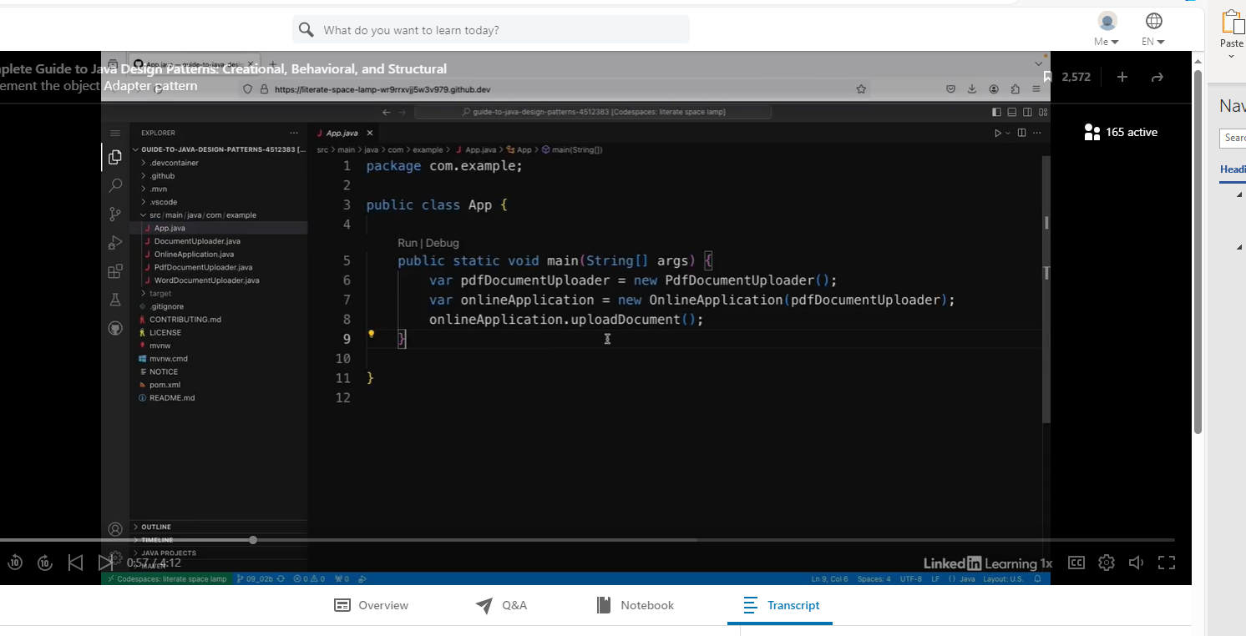

The code above works, but……

See code below:

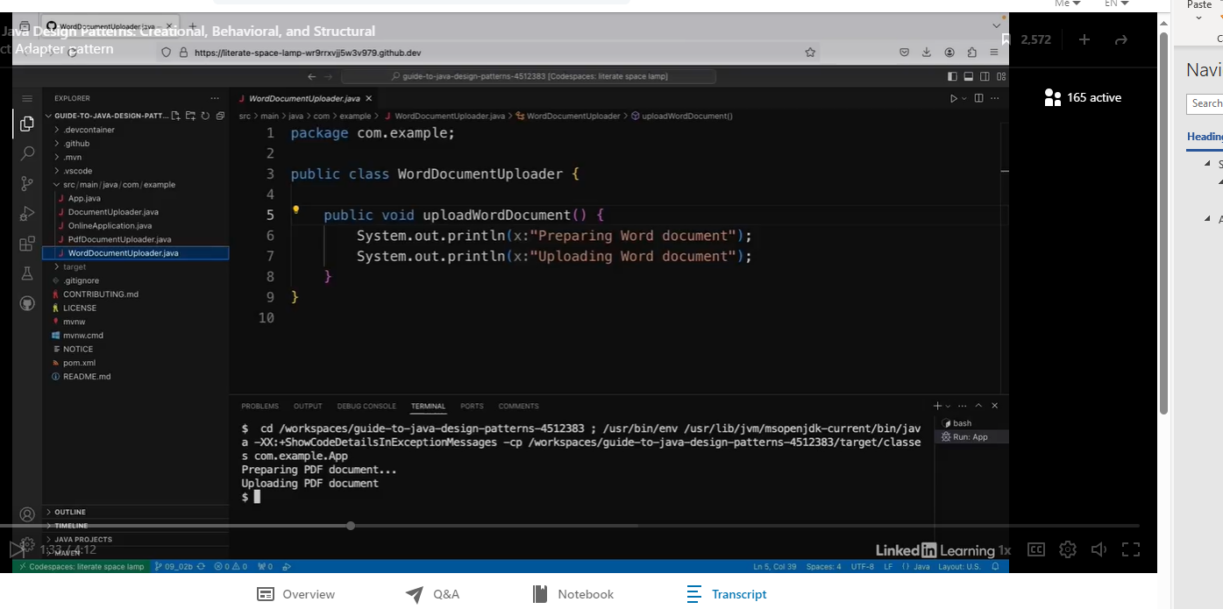

There's one more class that I haven't talked about yet, and that's the WordDocumentUploader class. So this class does something very similar to the PDF version, but it uploads word documents instead of PDFs. And the problem is that I can't use it with the OnlineApplication class because it doesn't implement document uploader, and that class expects a document uploader in its constructor. And I've decided I'm not going to touch any of the code in this WordDocumentUploader class. I'm just going to leave it as it is. So I'm going to solve this by creating an adapter. SOLID Principle O=”Open for extension, closed for modification.”

Create a new class called WordDocumentAdapter.

This adapter will accept the WorDocumentUploader class so we don’t need to touch the code. We did need to create the adapter class. This class will implement the DocumentUploader interface like we did with the PDFDocumentUploader. But we placed the WordDocumentUploader class in the adapter’s constructor and then executed the WordDocumentUploader’s uploadWordDocument method in the Adapter’s overrided upload method.

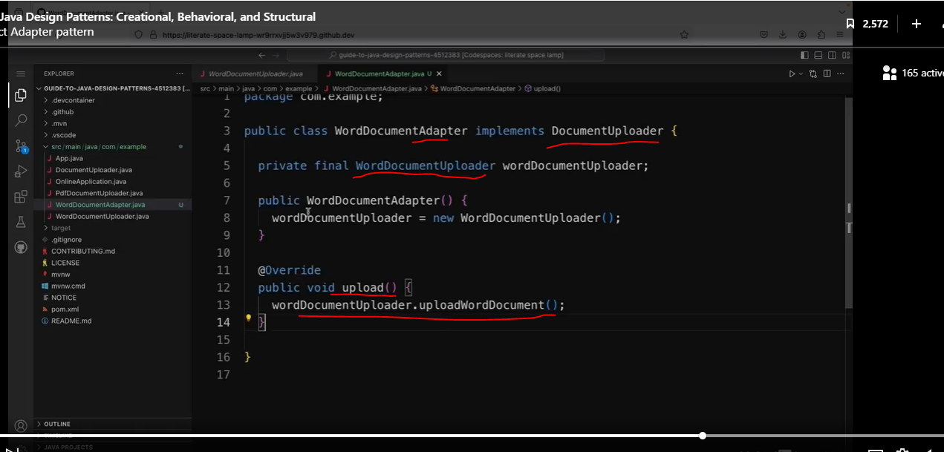

Now we will need to add the WordDocumentUploader class to the client. (Note: Review the OnlineAppliction class at the beginning of this chapter).

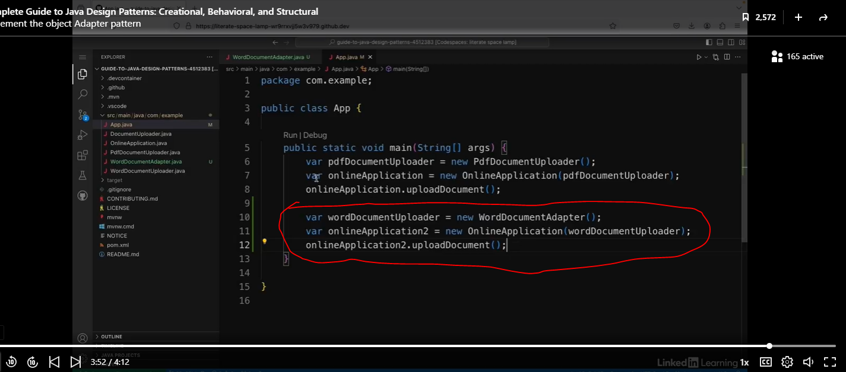

### Implement the Class Adapter Object

See code below.

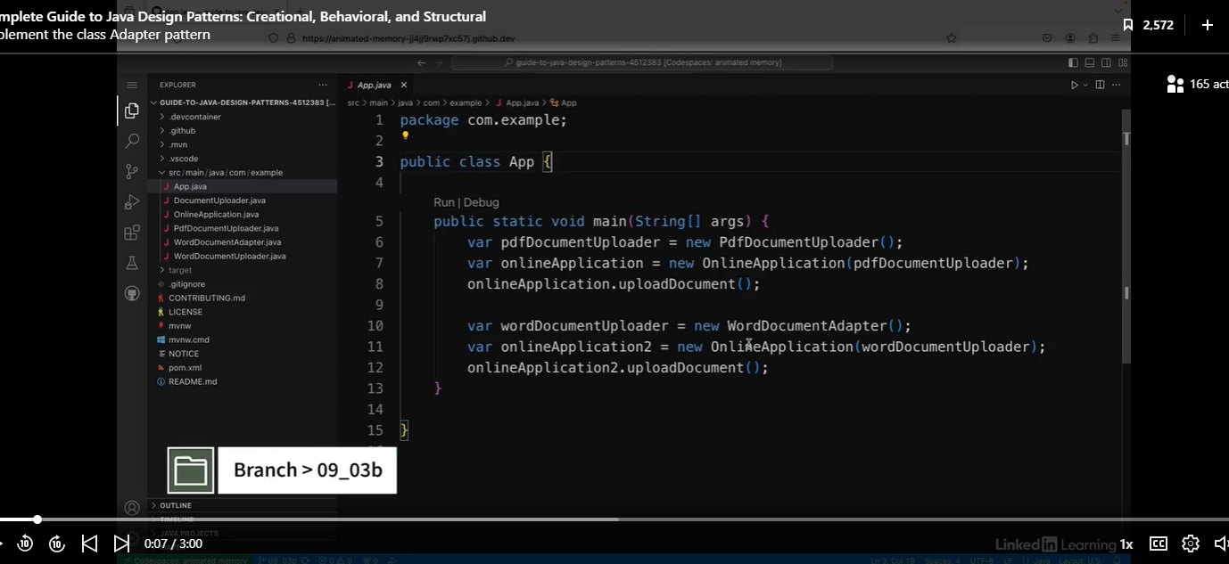

My app for uploading online job applications now uses the adapter pattern so that it can upload Word documents as well as PDF documents. But there's one small drawback. So if I run the app, I can see in the output that there's a very small difference between the messages it prints out. So it says "Preparing PDF document" and then three dots. But when it says "Preparing Word document," there's no three dots at the end. And I can't actually do anything about this because in the adapter, it just calls the method on the wordDocumentUploader objects. So if I want to be able to override the behavior of the adaptive class, it might be better to use the class AdapterPattern. So let's have a look at the Adapter class.

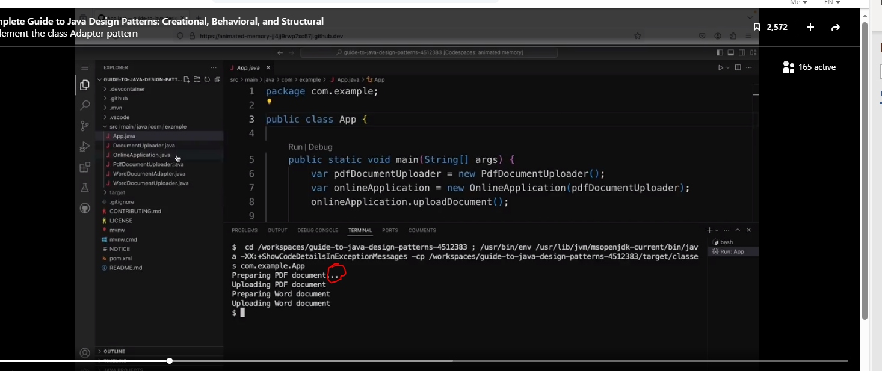

Let’s look at the WordDocumentAdapter

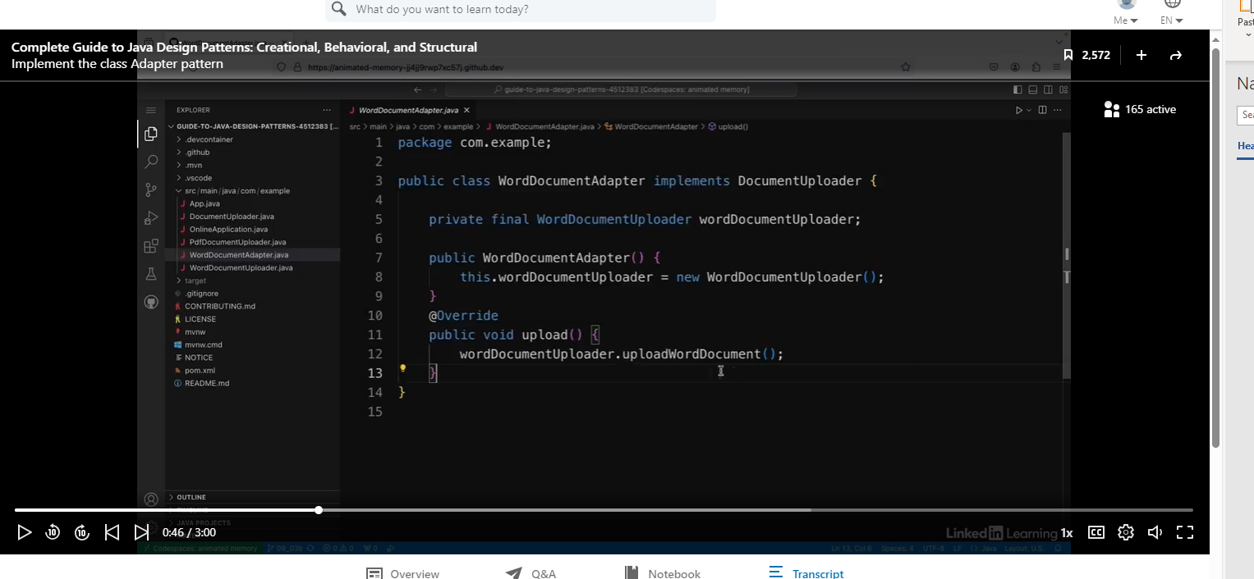

Now look at the changes we made. Now we can add the message with the three periods at the end of the sentence. Note that we added “extends WordDocumentUploader”, and we are overriding the uploadWordDocument method.

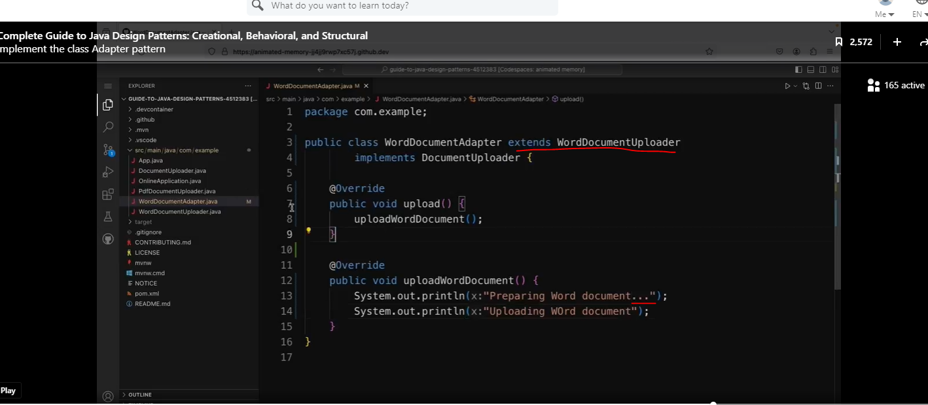

Note, I think the uploadWordDocument may be a result of duplicate code, so I wonder if I can call the original method, and add the three dots at the end of the phrase in the adapters’s uploadWordDocument methoed.

Note, the code works as expected, and we did not even need to touch the client code.

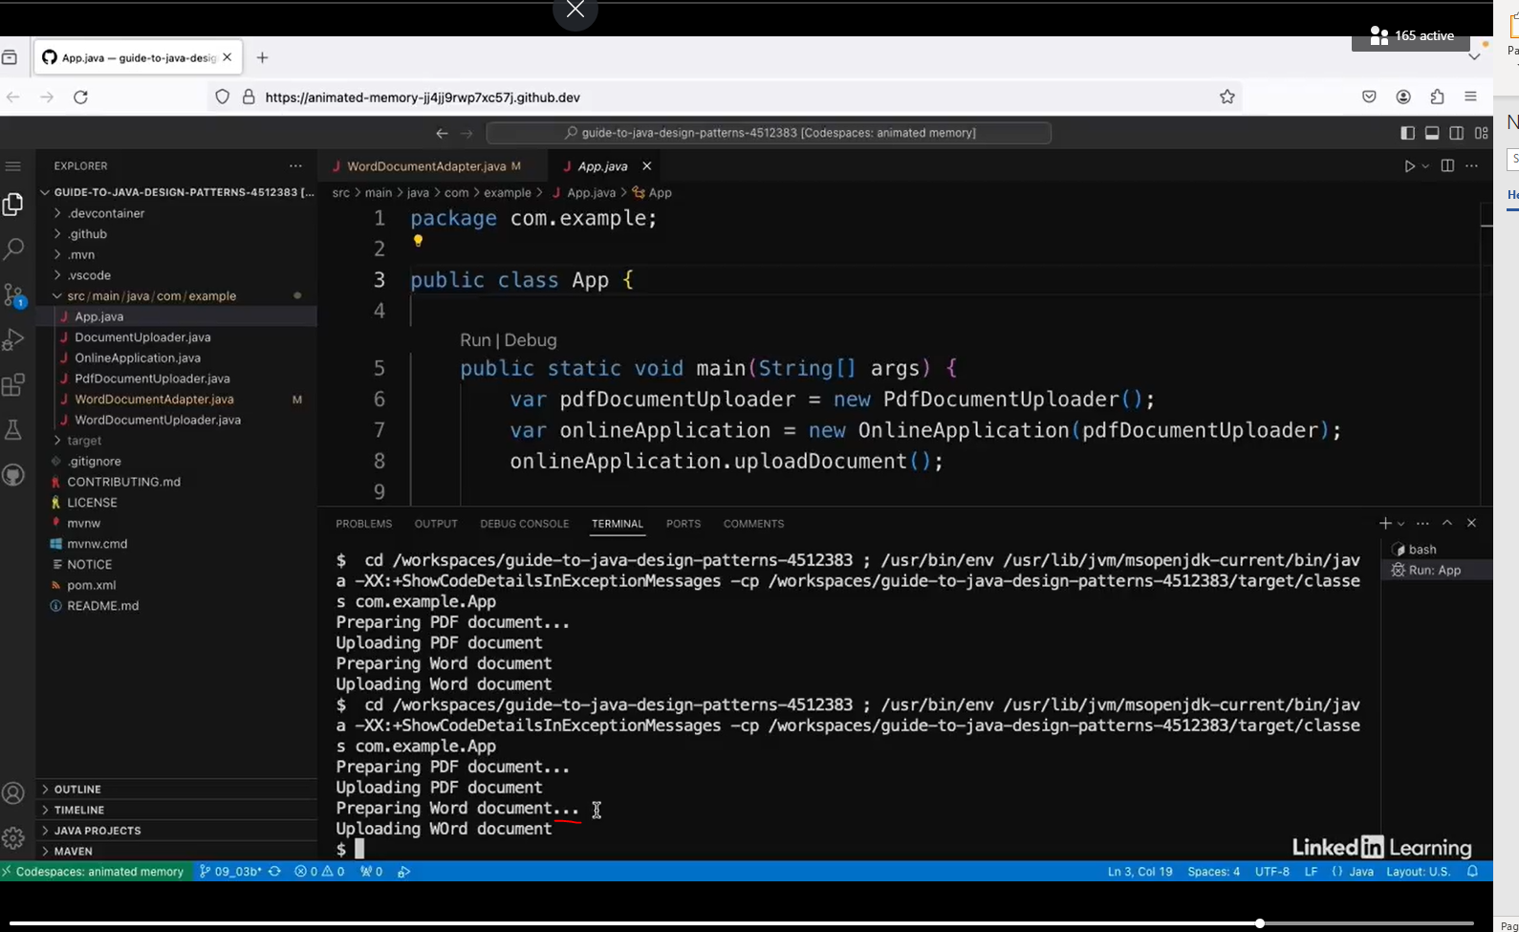

So that's the class version of the adapter pattern. One drawback compared to the object version is that with the object version, a single adapter can work with multiple adaptees. So, for example, with this WordDocumentAdapter, I can only use it now with WordDocumentUploaders. So, for example, if I had other file types, I wouldn't be able to use this adapter with them. I'd need different adapters for each one. So those are the differences between the two implementations, and which one you use depends on which of the drawbacks matters less to you for your use case.

## Bridge Pattern

### Understand the Bridge Pattern

The bridge pattern is all about using inheritance while maintaining flexibility. When we inherit from other classes, those classes become quite closely coupled together. But what if we want the child classes to have more flexibility about how they're maintained?

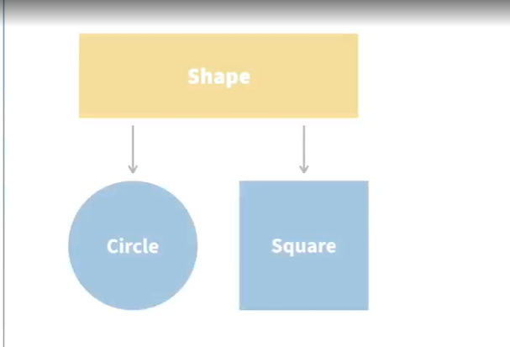

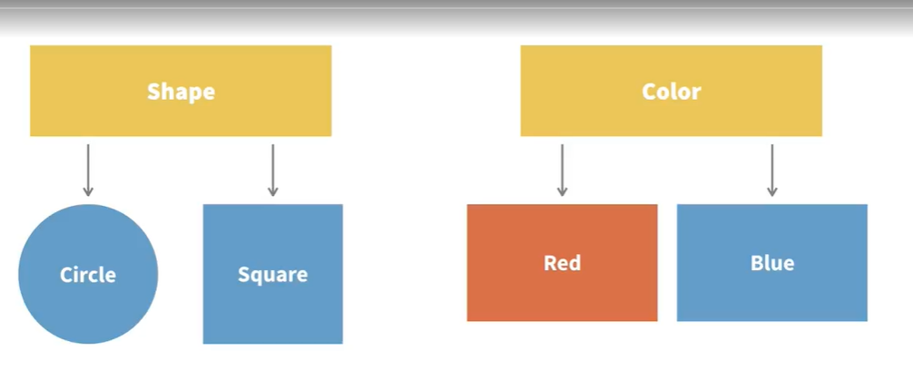

Let's say there's a hierarchy of shapes. So at the top is the shape interface. And below that, there are the classes that extend shape like circle and square and so on. But then say the different types of shape can also be different colors. So there's a separate hierarchy with an interface called color and different implementations called red, blue, etc. So how do we handle this? One option would be to add new classes for all the different shapes and all the different color combinations, but this would quickly lead to the need for lots of new classes.

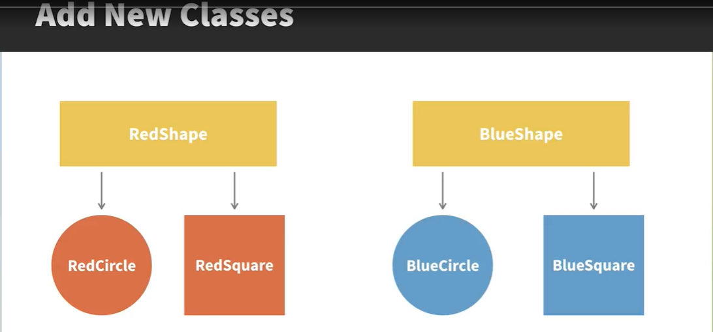

Solution: The Bridge Pattern

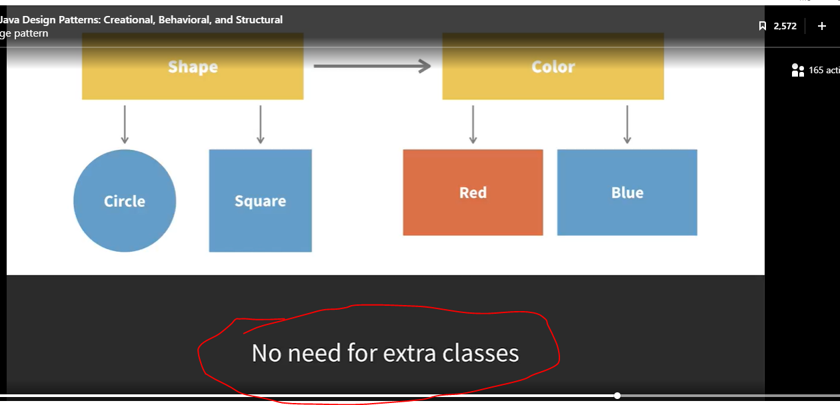

The solution is to use the bridge pattern. In this pattern, the shape interface has a color field, and this can be set for all the different objects. So that means we don't have to make all those extra classes. Instead, when a new concrete shape is created, the color is set as a field.

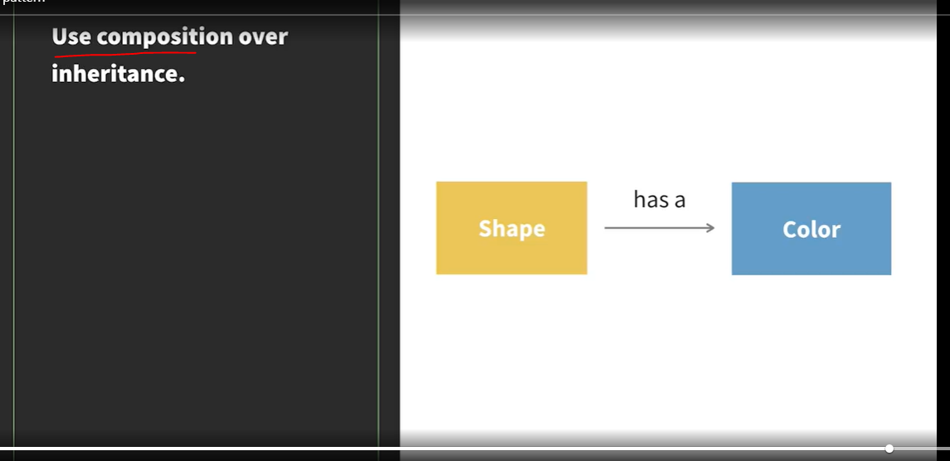

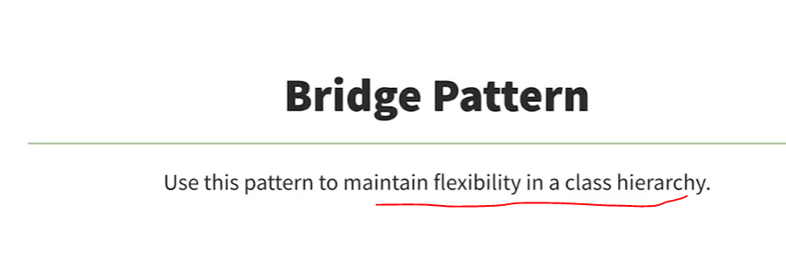

So the main idea for the bridge pattern is to use composition over inheritance. In this case, a shape has a color rather than a shape is a color. So you'd use this pattern when you have a class hierarchy, but you want to keep it flexible and allow the different concrete implementations to be configured in different ways.

### Implement the Bridge Pattern

See the interface below:

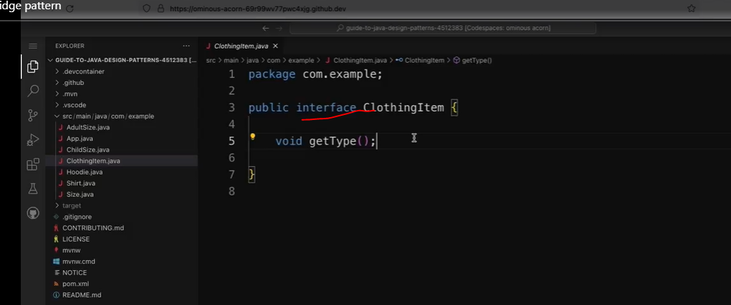

Let’s look at some classes that implement ClothingItem.

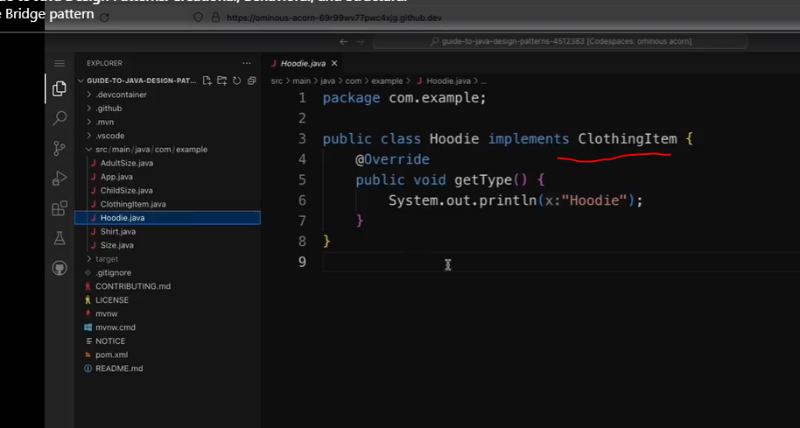

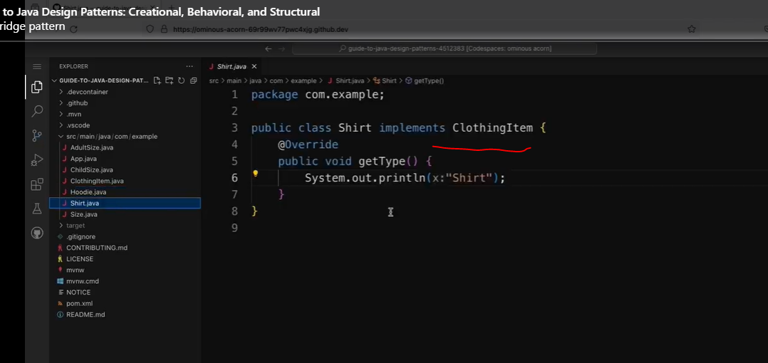

Check out the client code below:

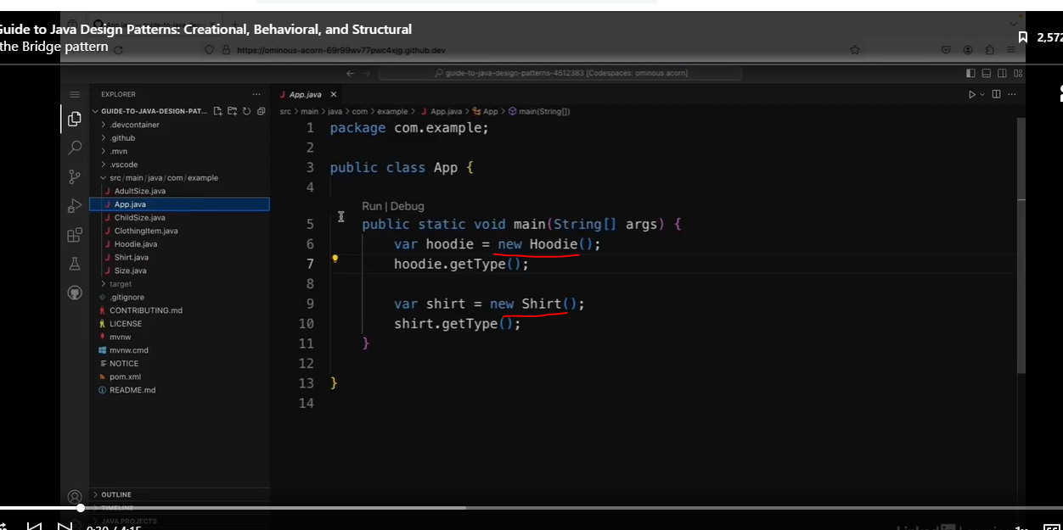

See the results below.

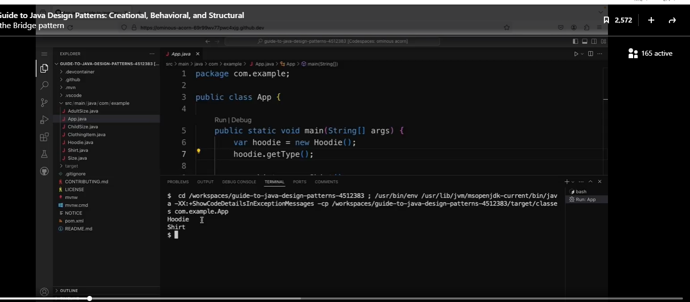

However, I also want the ClothingItem to be available in multiple sizes. So I also have an interface called Size. And this has a single method called get. And then there are two implementations of the Size interface, which are AdultSize and ChildSize.

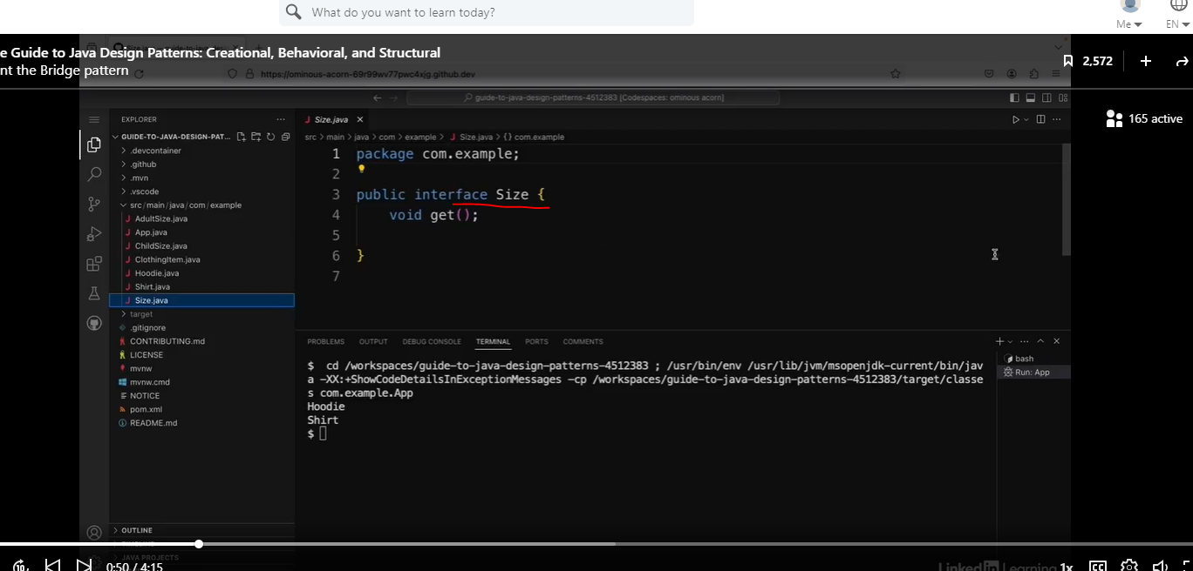

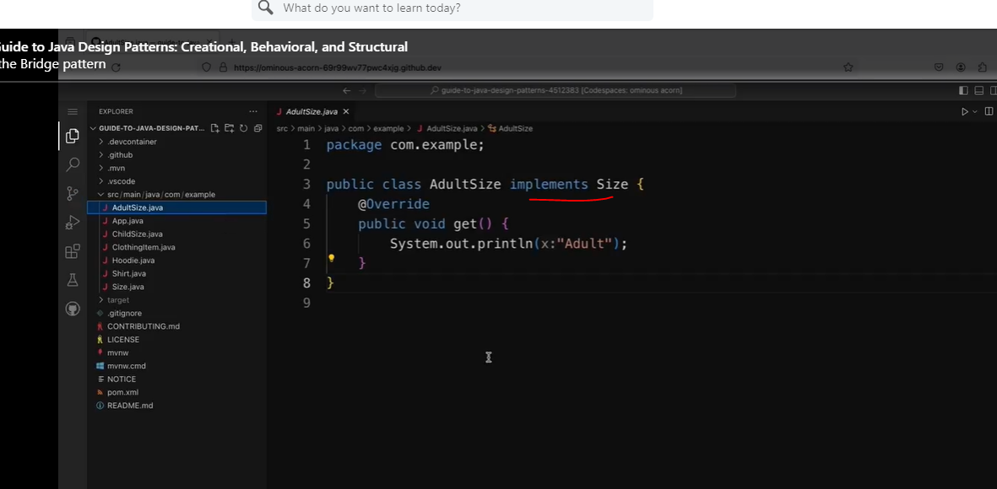

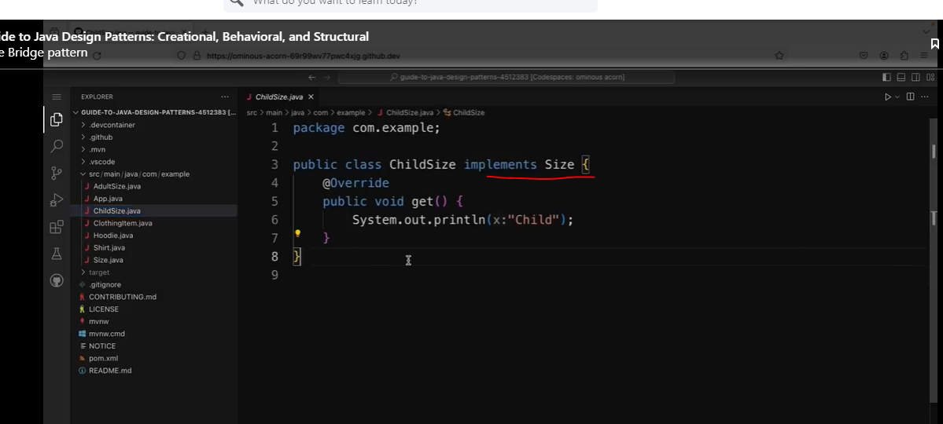

And in the ChildSize class in the get method, it prints out the word "Child." So I want to be able to have adult size hoodies, child size hoodies, adult size shirts, and child size shirts. But what's the best way to do this? I could refactor this so I have four different concrete implementations of ClothingItem, but that would mean that every time I create a new ClothingItem, I would have to create two new classes for it, one for each size. And if I add more sizes later on, I'd have to create a new class for each different clothing type.

Solution: Bridge Pattern

See the ClothingItem Interface below, and see how we refactor this.

We are adding the getSize method.

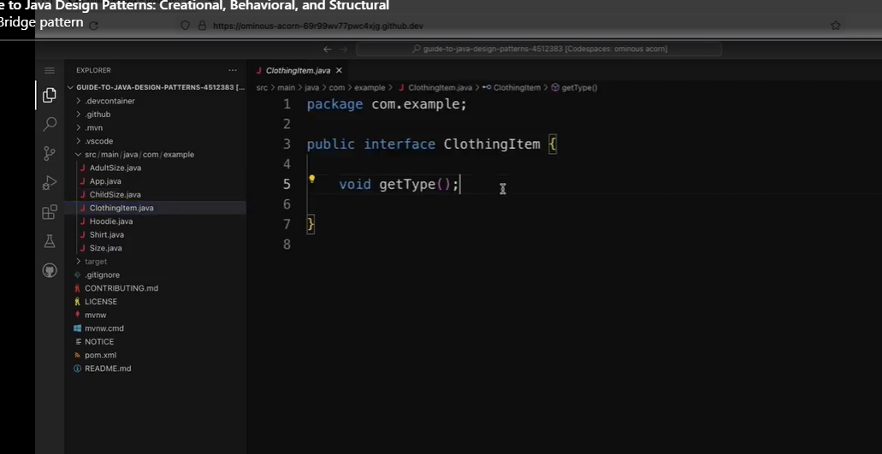

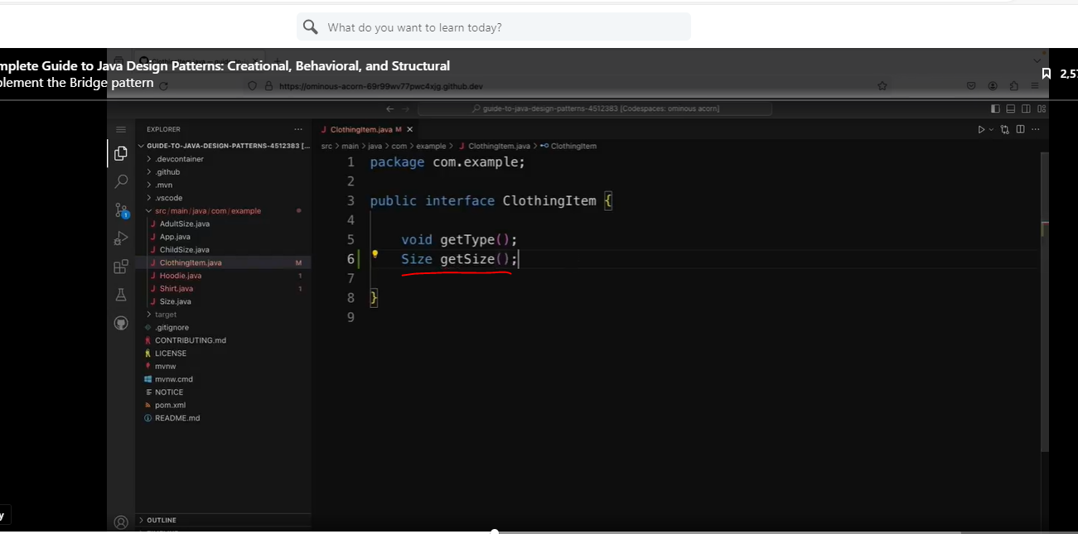

Now that we added a new method, we will need to update the concrete classes.

Look at the refactoring for the Hoodie class.

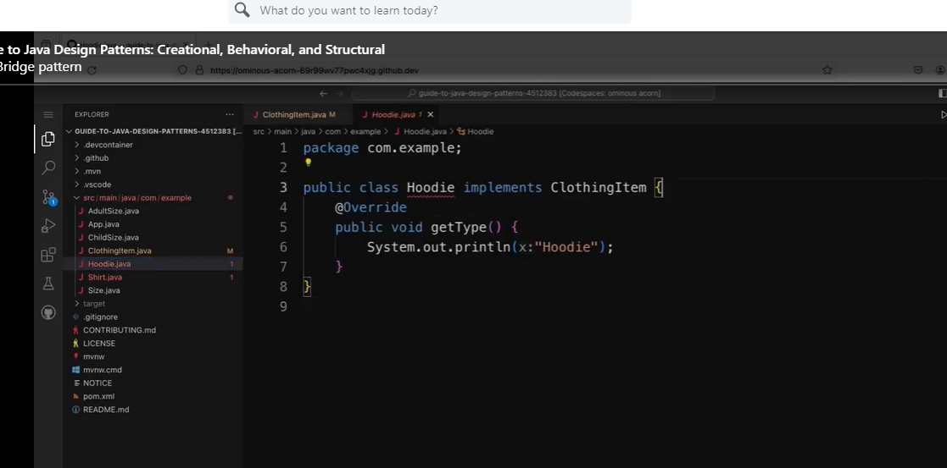

Note, how we added a field, constructor and the new overridden method.

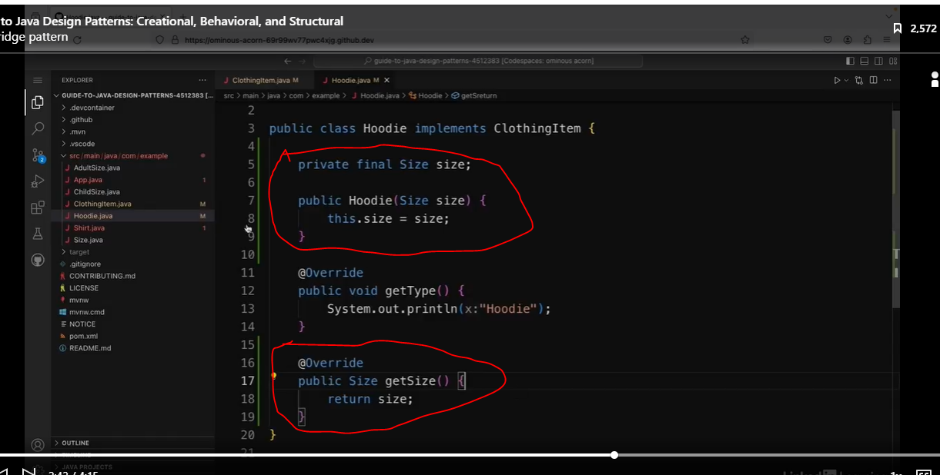

We have to do the same things to the Shirt class.

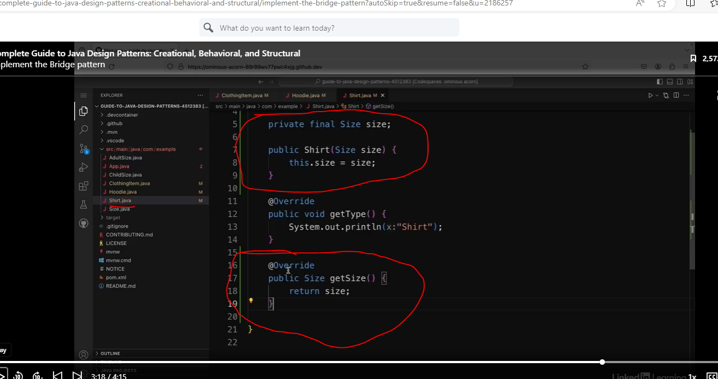

Now we will need to update the App class.

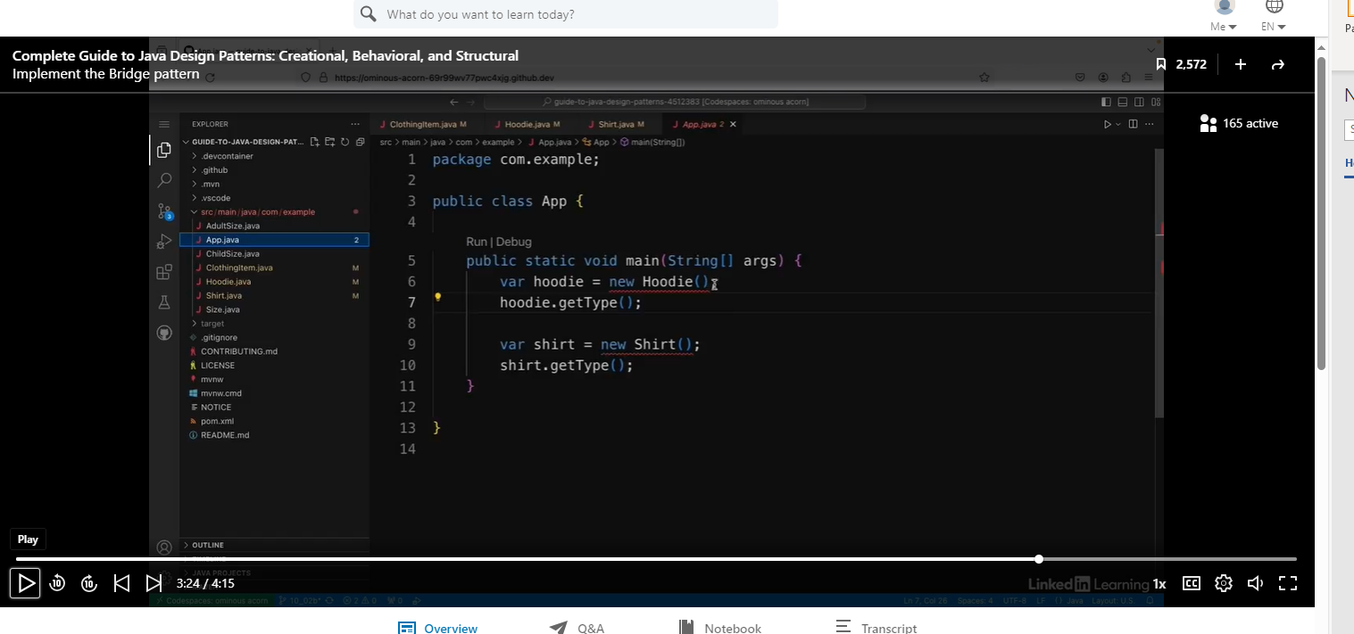

We can simply add a new object to the constructor. Note. I wonder if we could pass in method references instead?

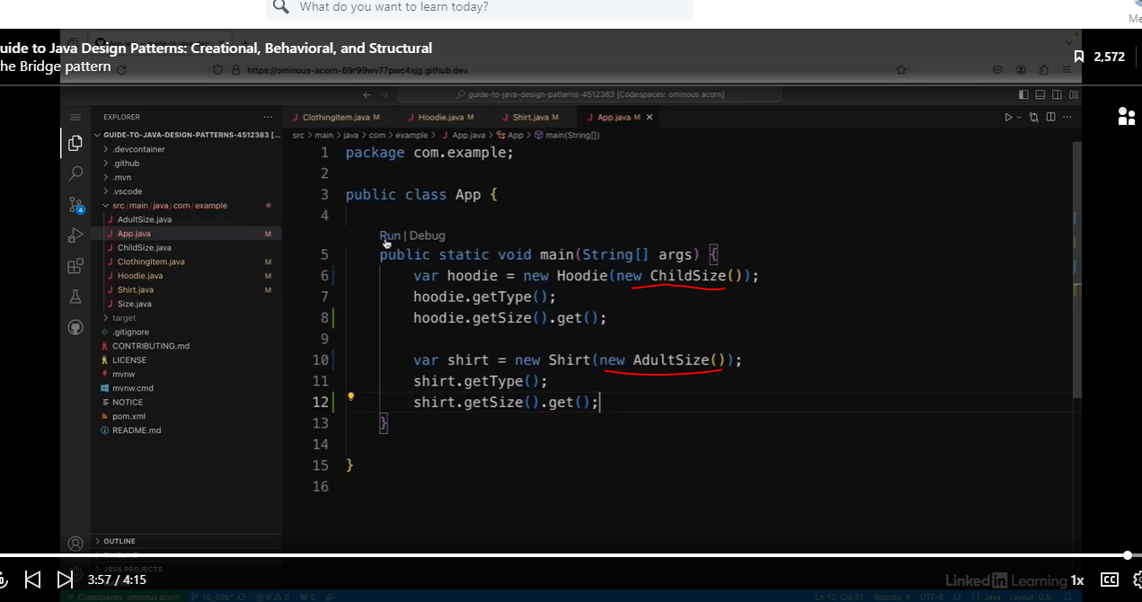

See the results below:

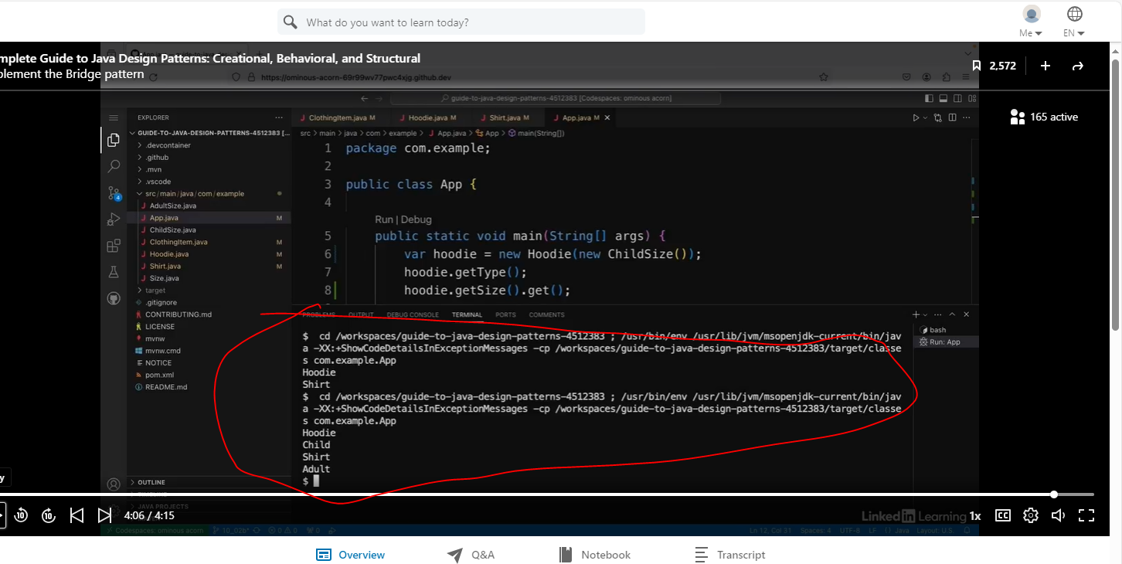

So this is how the bridge pattern can be used to avoid ending up with a complex hierarchy. Instead, I've used composition to pass in the configuration to the different classes.

## The Composite Pattern

### Understand the Composite Pattern

The composite pattern allows you to trace objects and groups of objects in the same way. Let's see how this looks with an example.

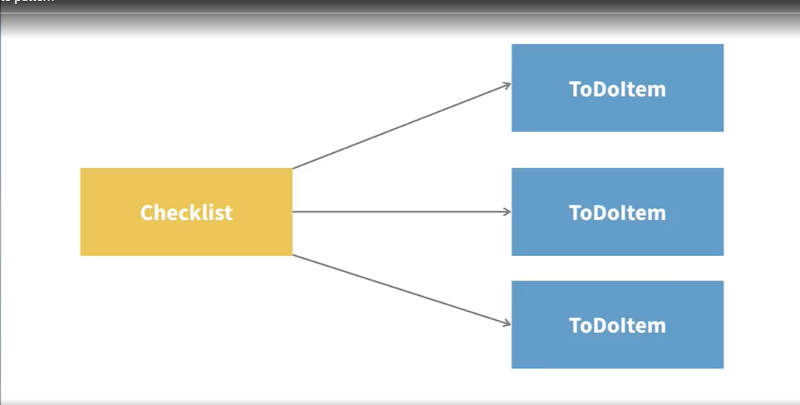

Say you have a checklist app that contains a checklist made up of to-do items. So there'd be a class called Checklist, and that class would contain a collection of ToDoItem objects. And let's say I want to have a method that will tell me if a to-do item has been completed or not. And I also want to have the same method in the Checklist class. The checklist is complete if all of the to-do items in the checklist are also complete.

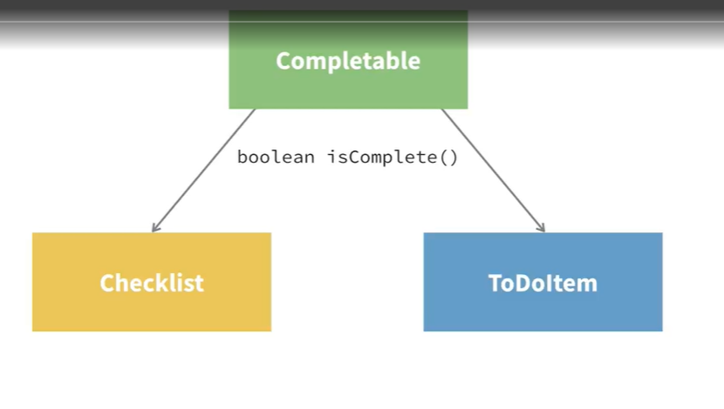

The way I do this is with the composite pattern, so you'd have either an interface or an abstract class that both the composite and the parts of the composite both inherit from. So in the interface, I could have a method called isComplete. The ToDo class can implement this. And then in the Checklist class, it can also implement this same method. And for each to-do item in the list, it can call this isComplete method for each of those items.

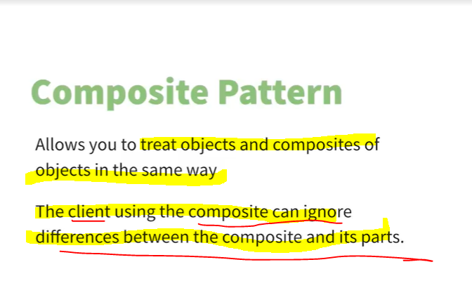

So the composite pattern lets you treat objects and composites of objects in the same way. And it also means that the clients using the composites can ignore differences between the composite and its parts. For example, a client could use the isComplete method for the checklist and also for the individual to-do items in the same way, because they inherit from the same interface.

### Implement the Composite Pattern

See code below:

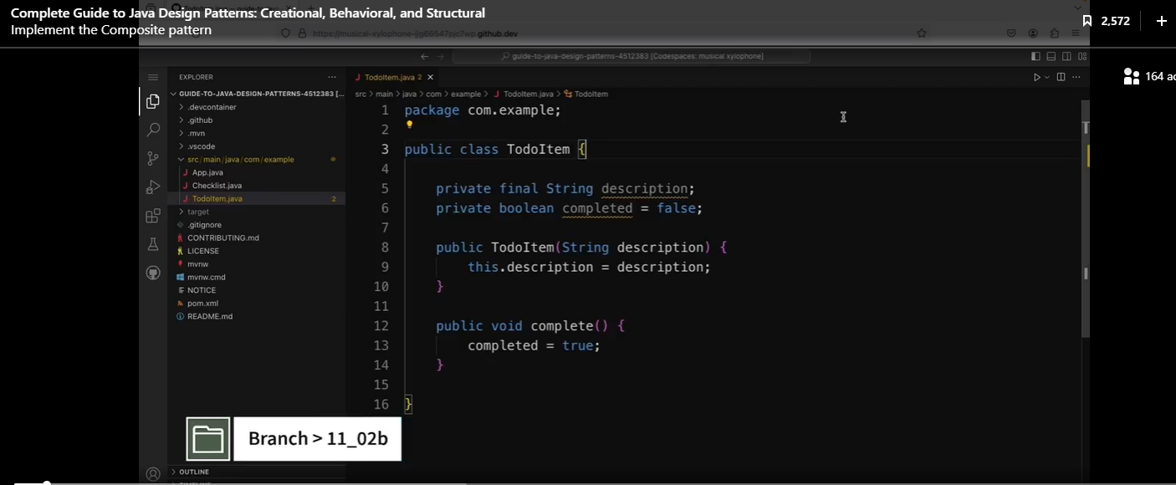

The app I have here is an implementation of a checklist, and I'm going to be using the composite pattern to make it easy to handle groups of to-do items in the checklist.

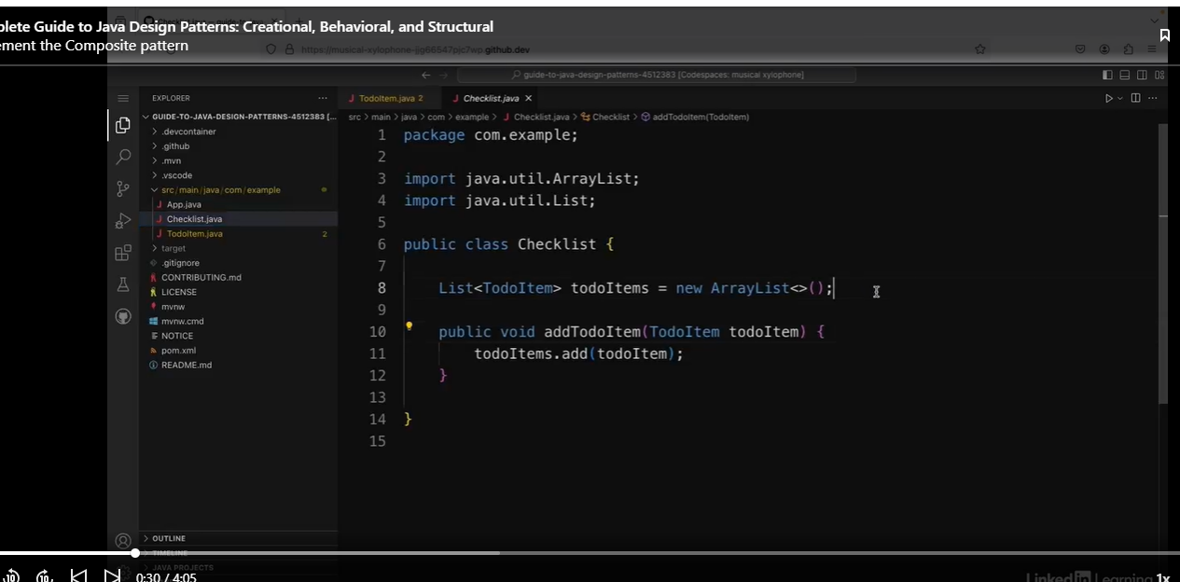

See the client code below:

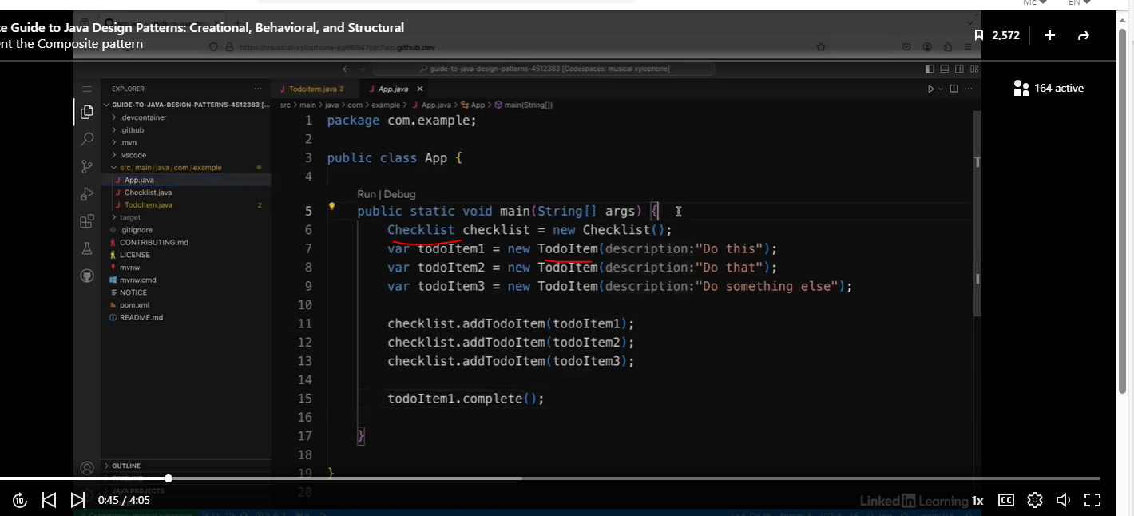

A checklist in this case is a composite because it contains a collection of other similar items.

Check out Completable interface.

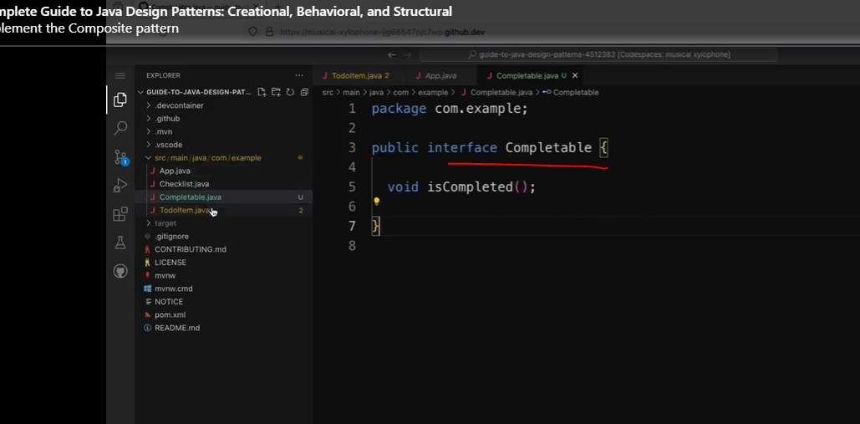

Now we are going to have TodoItem implement Completable, then override the methods from that interface.

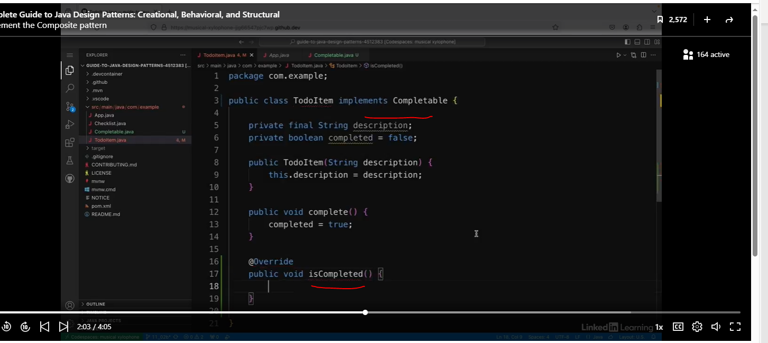

Now we will populate the isCompleted method.

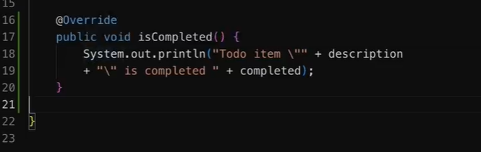

Now we will refactor the CheckList class by implementing the Completable interface.

Note the method reference we created.

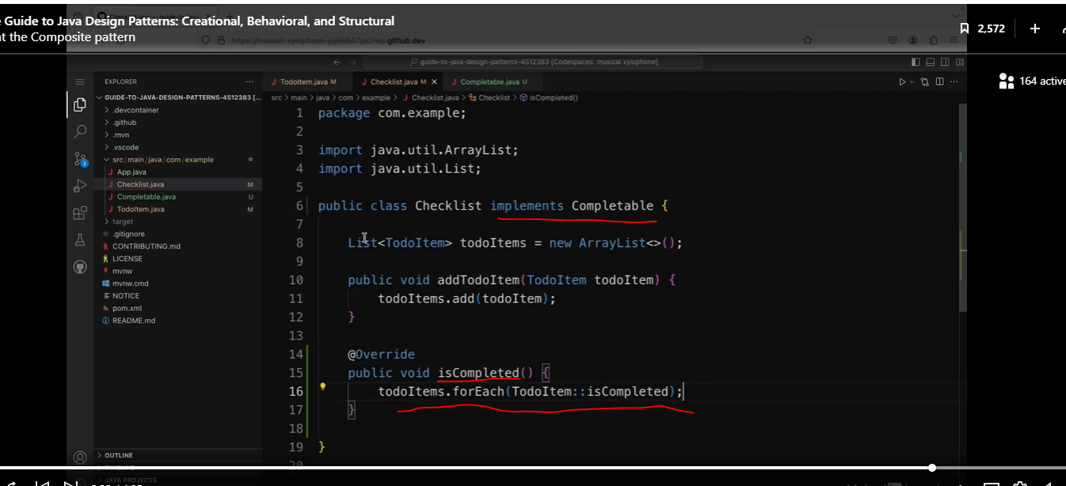

Now we will go back to the App class (client). It looks like we don’t need to make any changes.

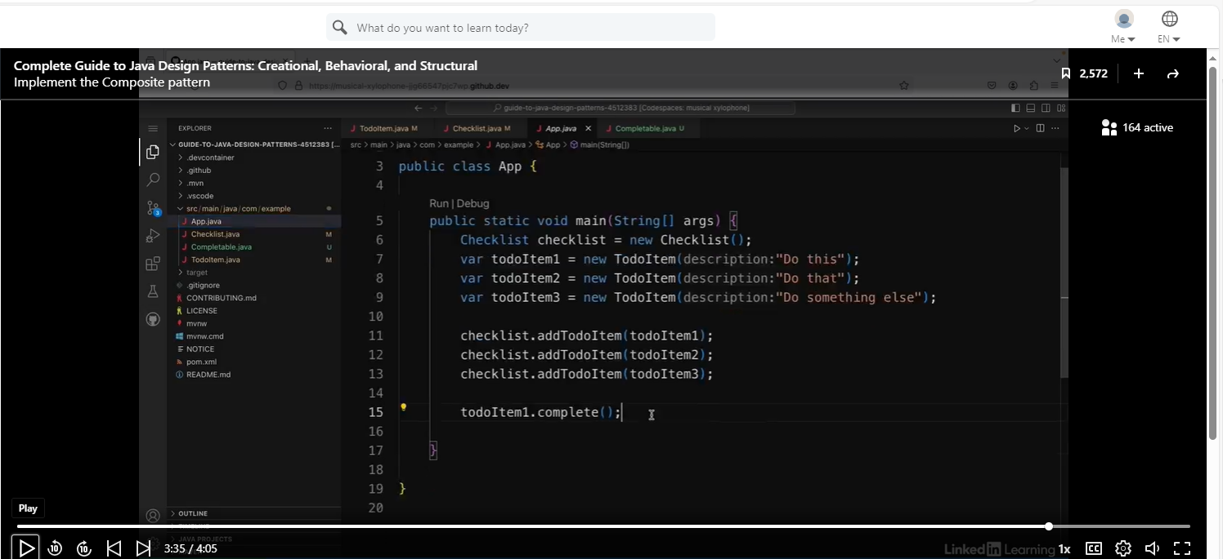

But we will add the method call at the bottom:

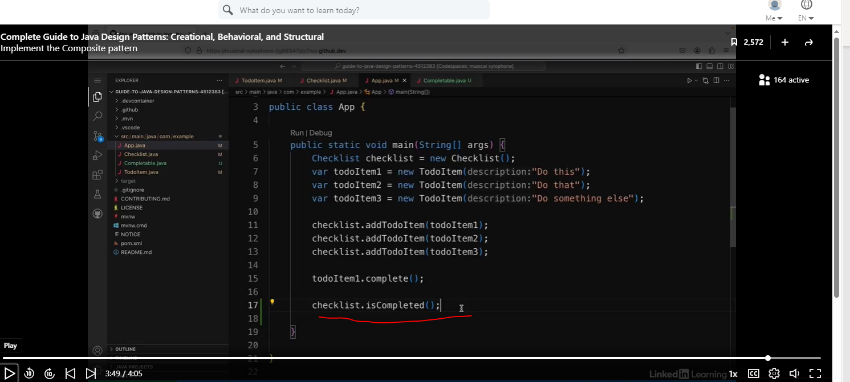

See results below:

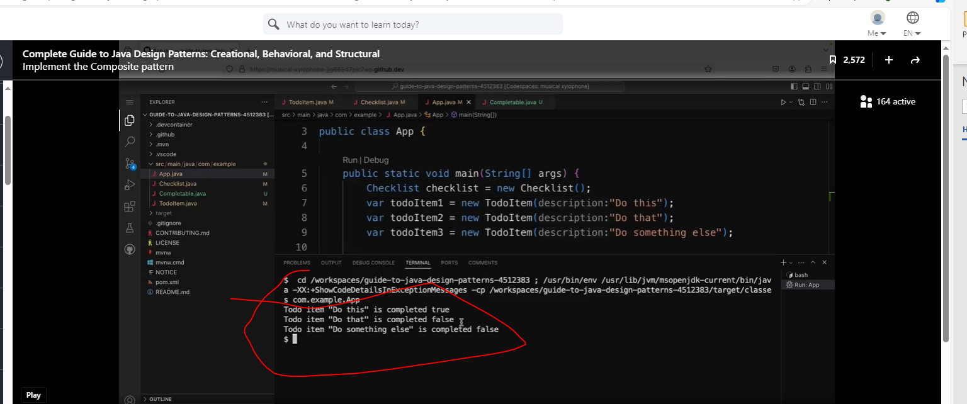

## The Decorator Pattern

### Understand the Decorator Pattern

The decorator pattern change the behavior of an object without having to create a new subclass for that behavior.

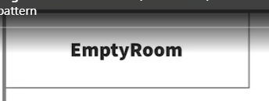

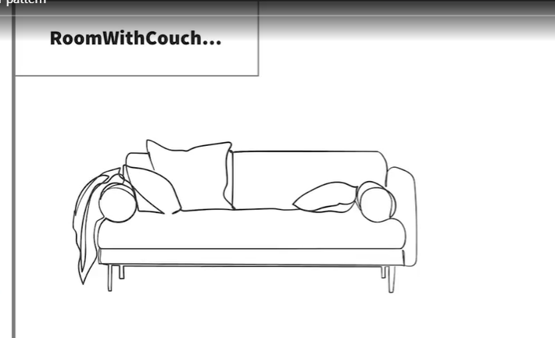

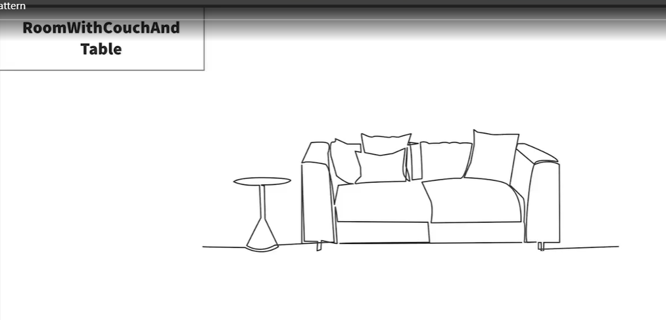

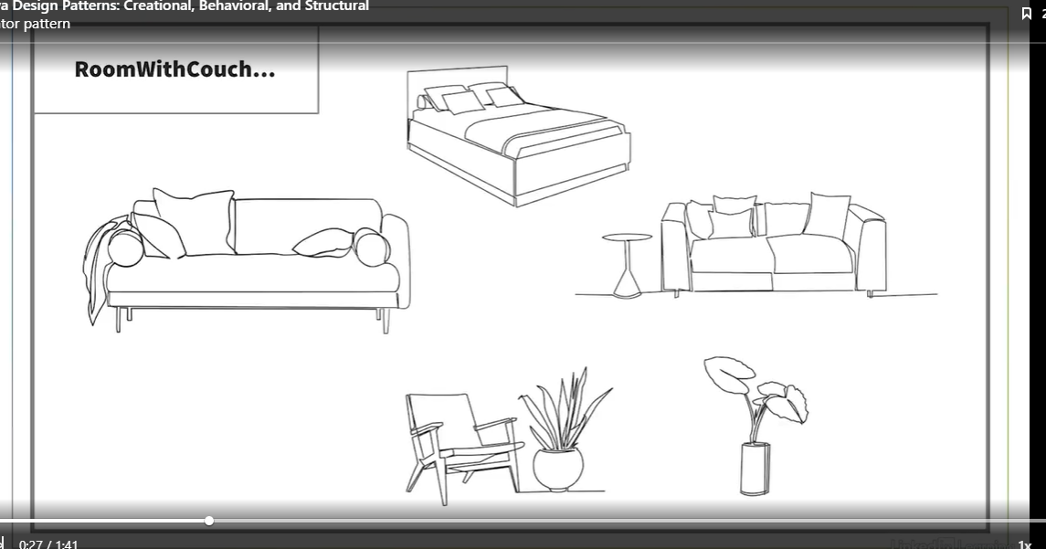

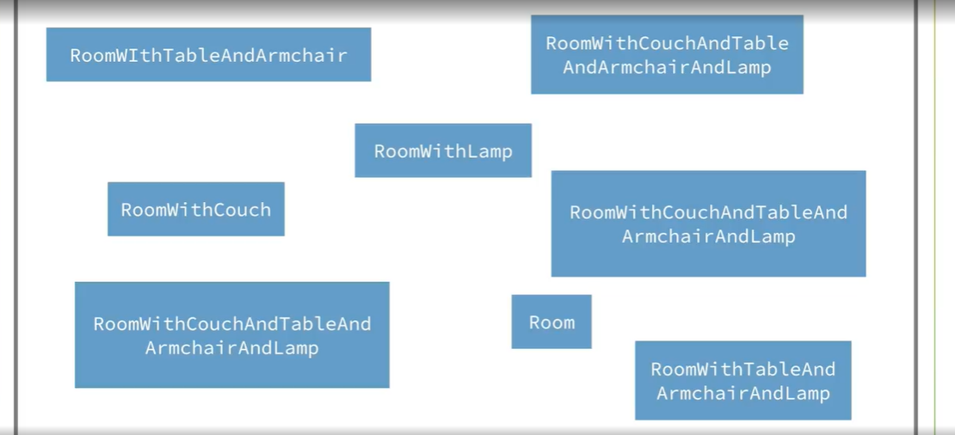

So say, for example, that you have an app for creating rooms that are decorated in different styles. So you might start off with a blank EmptyRoom class, but then you want to have a room with a couch in it. So you'd have a room with Couch class. And then you might have a room with a couch and a table in it. So you'd have a class representing a room with a couch and a table. And then there might be lots of different combinations for lots of different types of furniture. You can see that if I had different subclasses for all these different possible combinations, it would get out of hand very quickly. This slide only shows a few different possible combinations of decorated rooms, and there's already a lot on there.

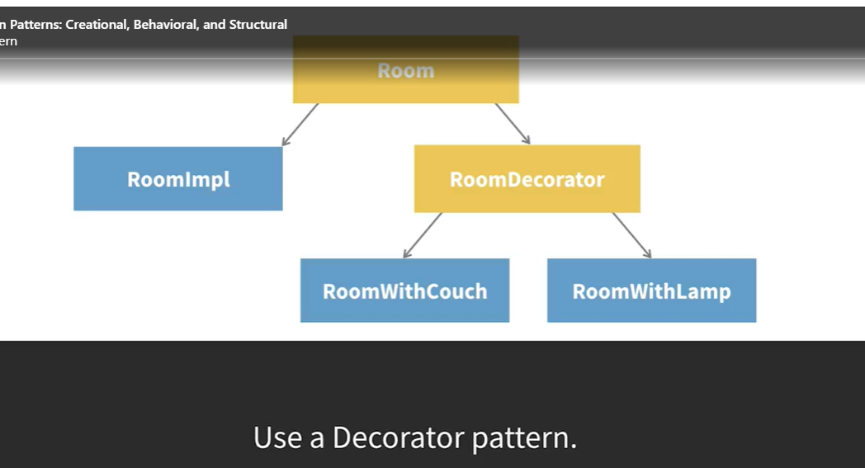

The first part of this pattern is that you have an interface at the top. So in this case, a Room interface, and then a concrete implementation of that Room interface. In this case, this room implementation represents an empty room with no decoration. Next, there's another interface or an abstract class underneath the Room interface called RoomDecorator. Then there were concrete implementations of this decorator class for each of the different decorations you want to have.

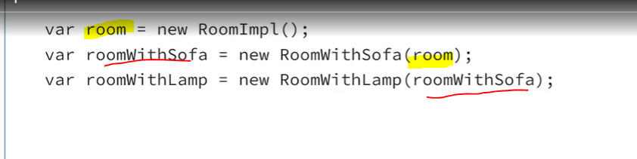

These decorations take a concrete room object as an argument to their constructor. So, for example, you create a room object and then a room with a sofa decorator and pass in the room objects. And you can do this as many times as you want. For example, you can create a room with a lamp and then pass in a room with a sofa objects. So then you'd end up with a room with a sofa and a lamp.

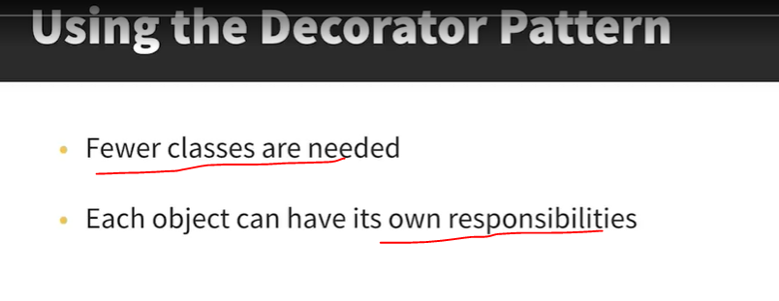

### Change Behavior Dynamically with a Decorator

See code below:

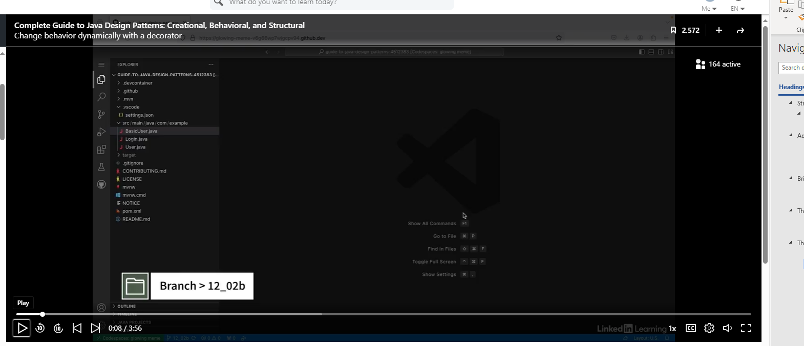

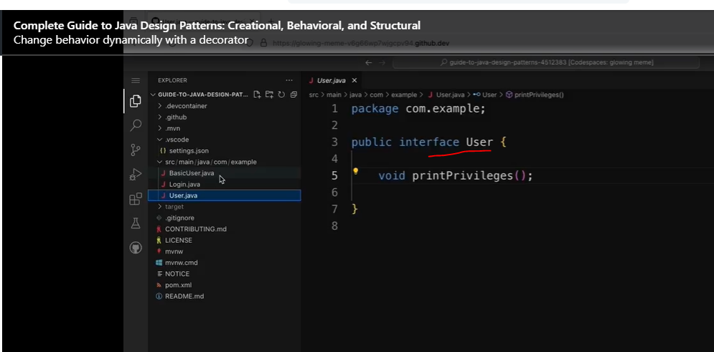

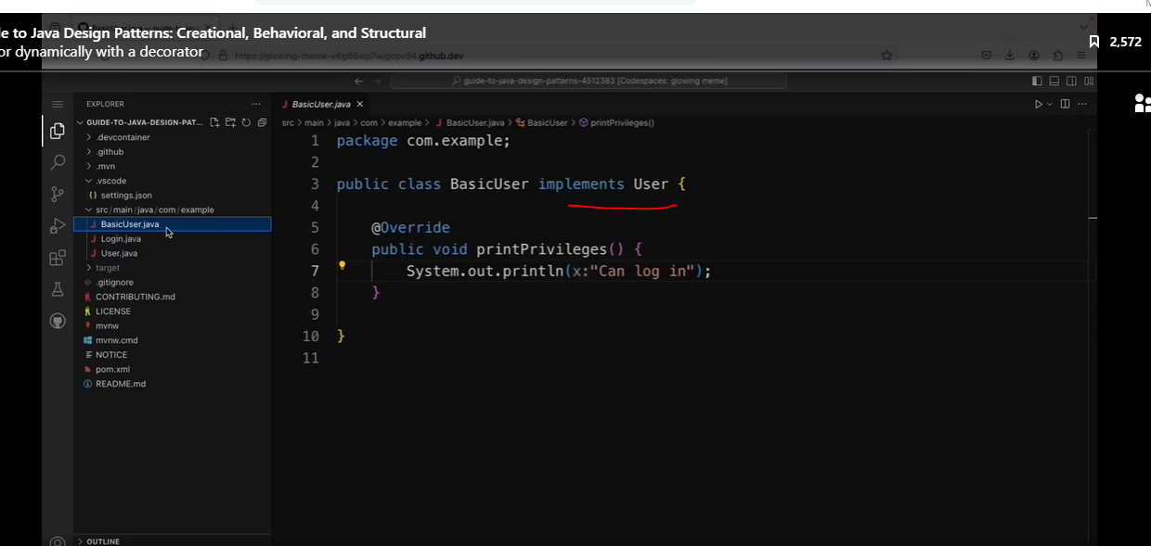

In this example, I have a simplified version of an app for logging in users to an application, and I'm going to use the decorator pattern to be able to create users with different privileges. So at the moment, I have an interface called User which defines a method called printPrivileges. And then there's a class called BasicUser which implements user. And inside the printPrivileges method, it prints out a message saying "Can log in." So that means that a basic user has the privilege to log in to the app. So I want to be able to have users with different combinations of privileges. So I'm going to create a Decorator class to handle that.

#### Different combinations of User Privileges

##### Decorator Class

Note this abstract class implements an interface, and the private variable uses the interface it implements. (User interface).

Also note, this abstract class does not have an abstract method.

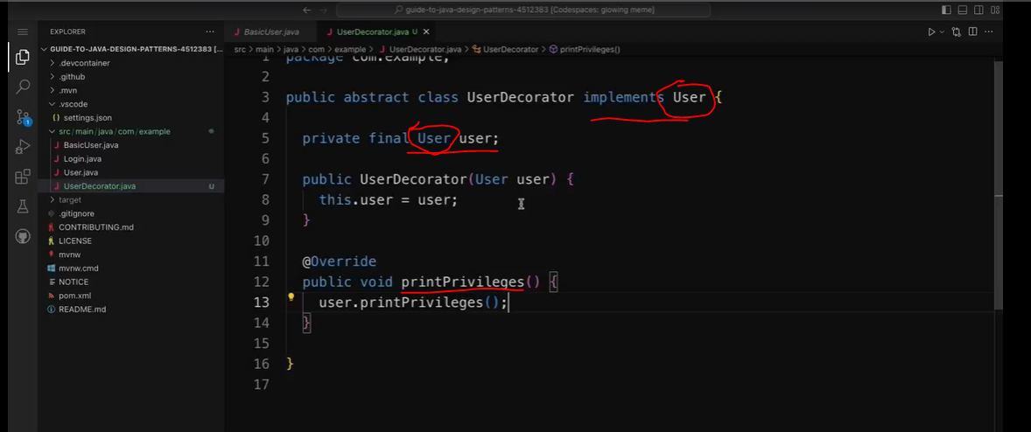

Let’s create an AdminUser class.

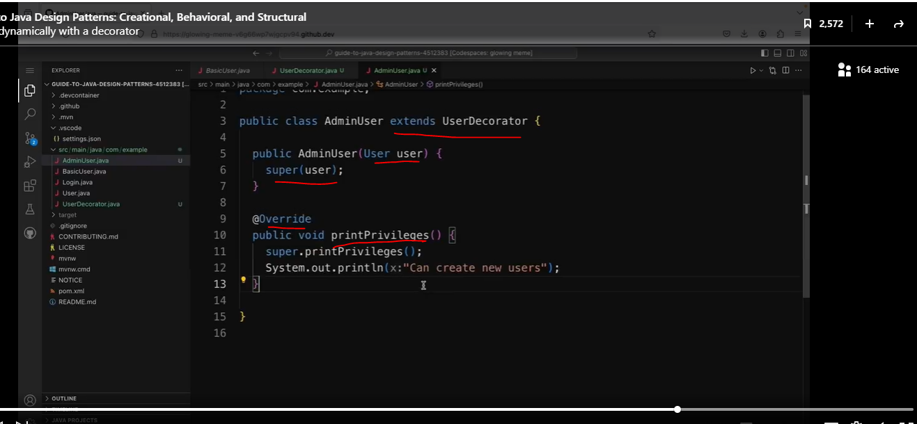

See client code below:

We will add the admin user to the client code.

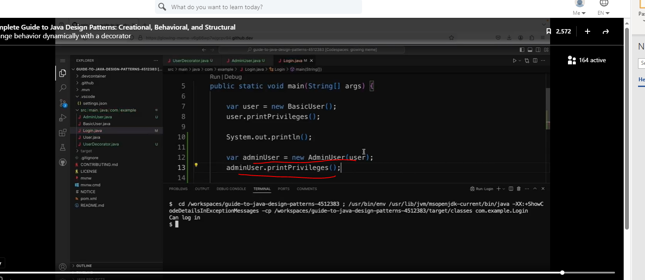

Both User and Admin User rights are displayed.

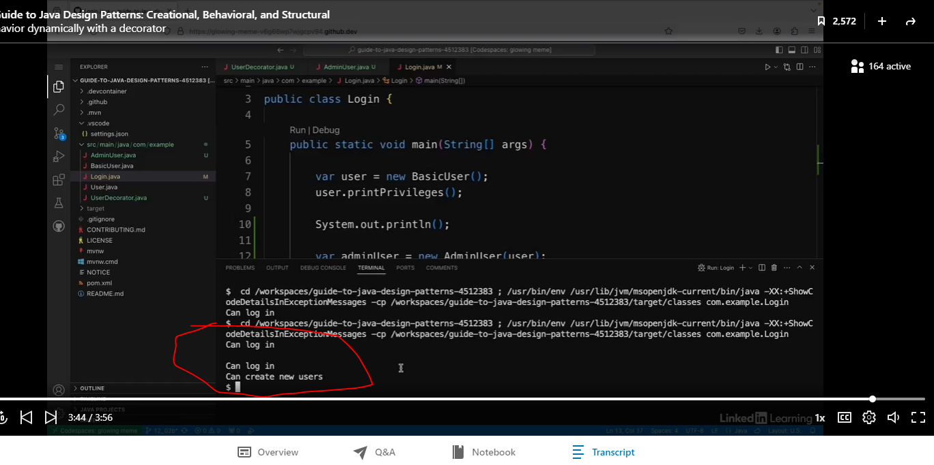

So that's how you can use the decorator pattern to add functionality dynamically to objects.

### Add Multiple Decorators to an Object

See code below:

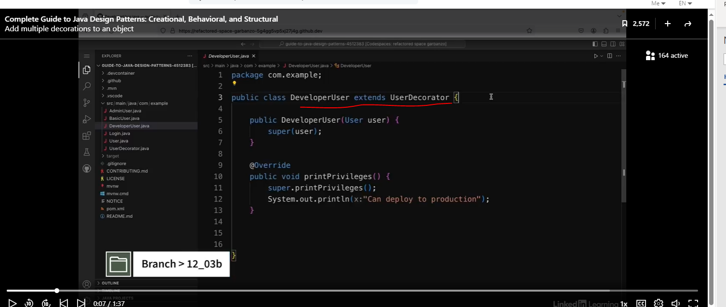

In this login app, I'm using the decorator pattern to add other privileges to a basic user. So so far, I've added admin privileges to a user. But let's see how it would work if I wanted to add other privileges on top of that as well.

Let’s go back to the client code.

Currently, we have a basic user and an admin user.

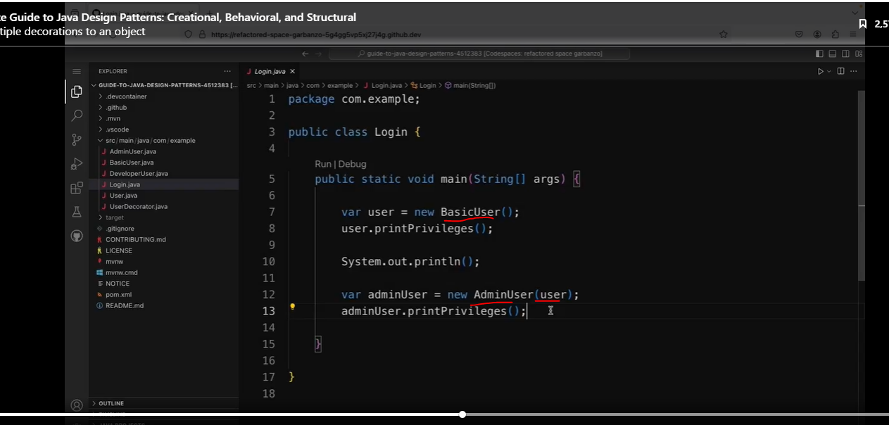

Now let’s add the developer user. We are chaining different user privileges together.

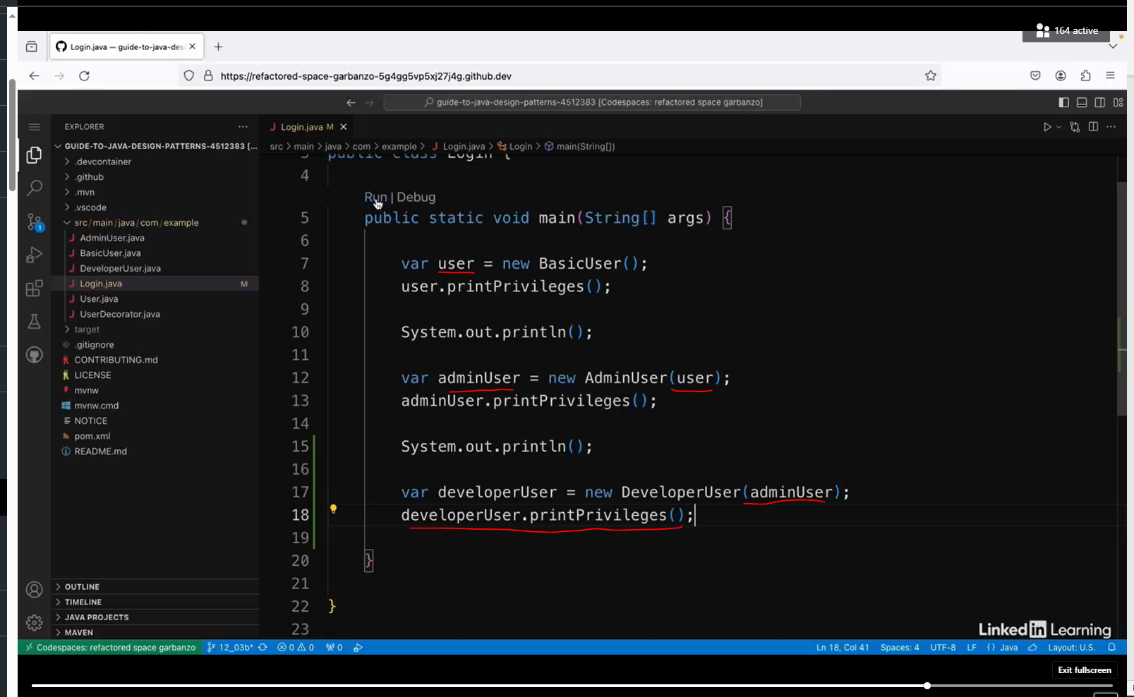

## The Façade Pattern

### Understand the Façade Pattern

#### Hiding Complexity

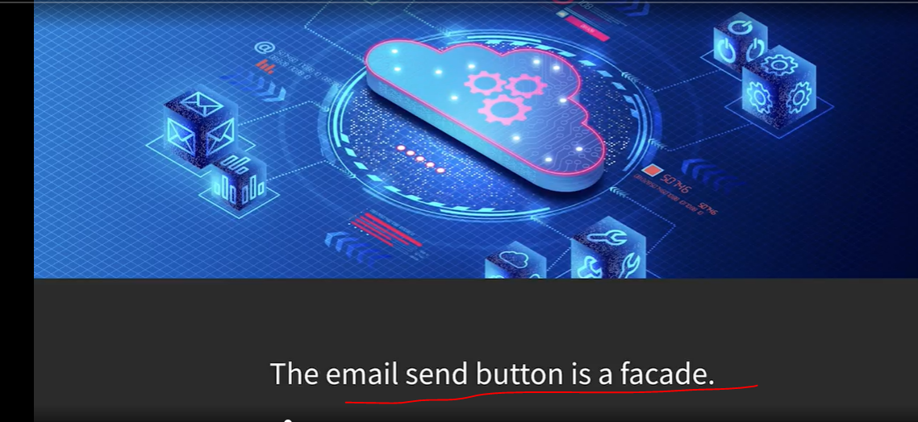

The word facade can mean a deceptive outward appearance, and in this case, it means that you have a simple interface that hides the complexity of the code behind it. For example, think about when you write an email and click on "Send." There's a lot going on behind the scenes when we click on that send button, but most people aren't thinking about the technical things behind the scenes every time they send an email. And we certainly don't need to know how email protocols work in order to send one. So in this example, the send button is a facade that hides the complexity of sending an email.

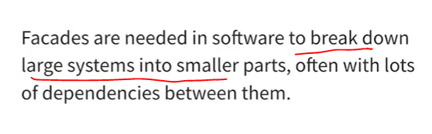

Facades are needed in software because it's common to break large systems down into smaller parts, often with lots of dependencies between them. This is generally a good thing because it makes systems more reusable and easier to customize, but it can also make it harder to use.

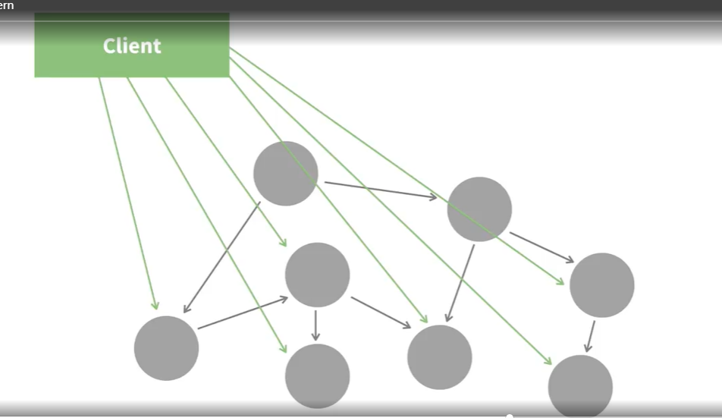

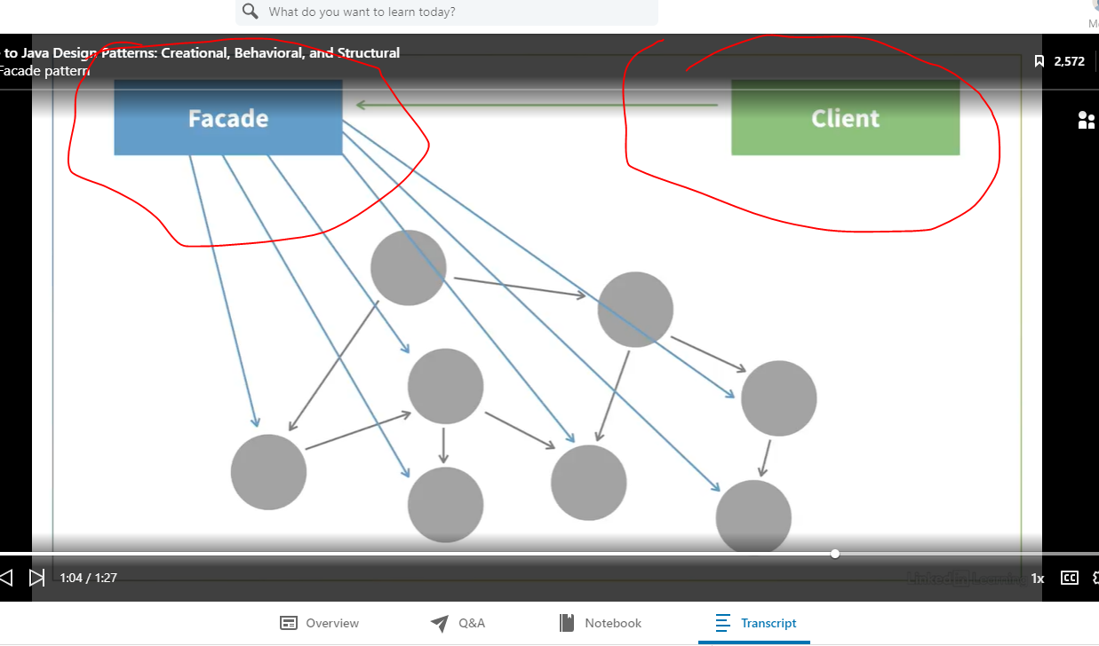

A client that wants to use a system like this would have to interact with all the classes underneath. This means that it can make the most of the possible customizations, but sometimes the client might not care about those and it still has to use all the classes anyway. So a facade is used as a single, simpler interface to these complex systems. Then the client can just use this simple facade interface to do everything at once. As well as being simpler, it helps to minimize the dependencies between the client and the subsystems. The other nice thing is that you don't have to use the facade if you don't want to just because it's there. You can directly access the classes or subsystems underneath if you want to. So to summarize, the facade pattern can be helpful when you want to provide a simple interface to a complex subsystem.

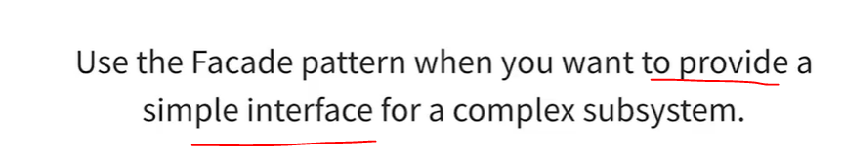

### Implement the Façade Pattern

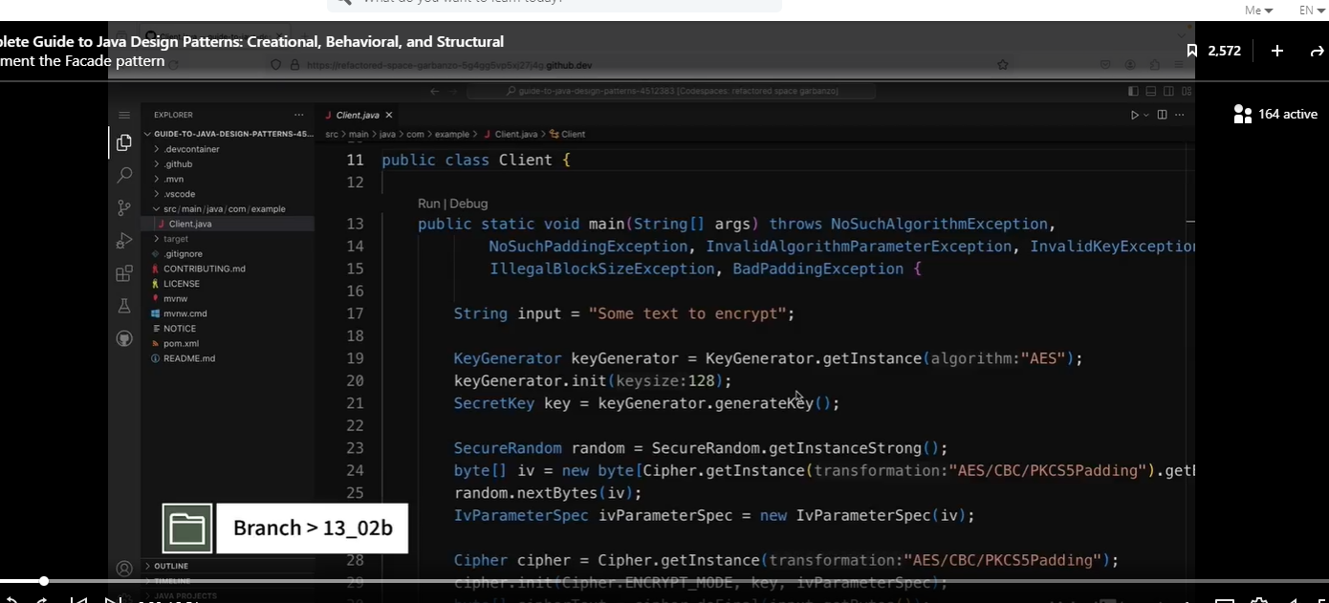

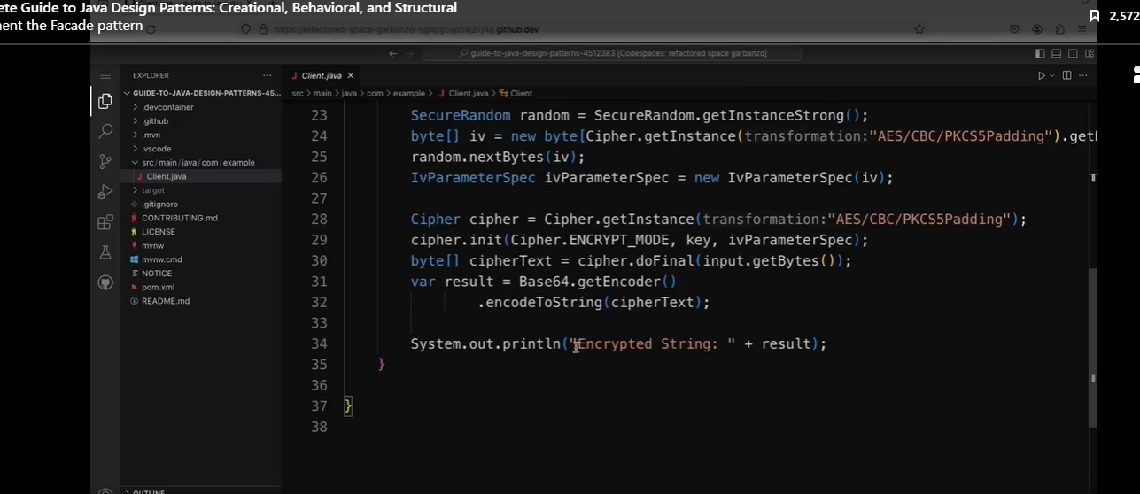

I have an application here that's used for encrypting strings. Encryption is quite a complicated process in Java with quite a few steps in it, and I'm using lots of different classes from the JDK here to do this.

The code above is complicated.

Running the code above will produce the result below.

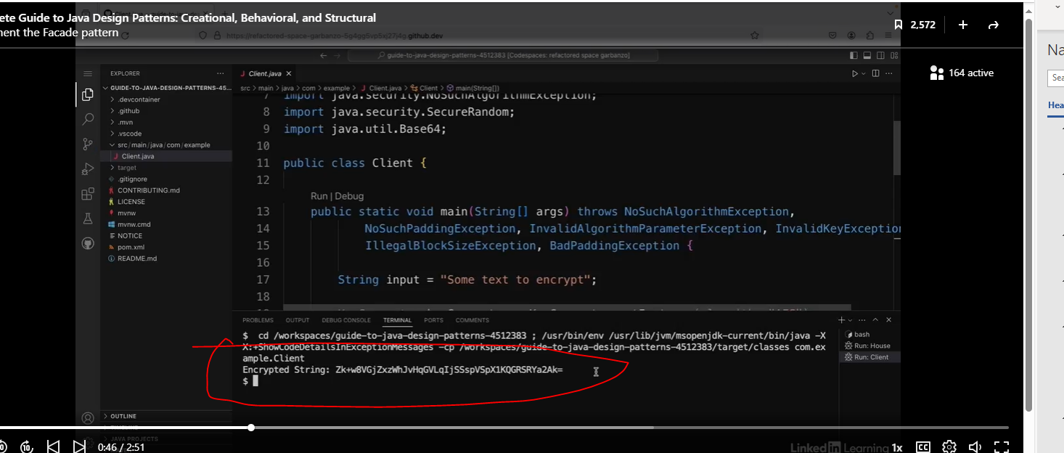

#### Let’s create the EncryptionFacade

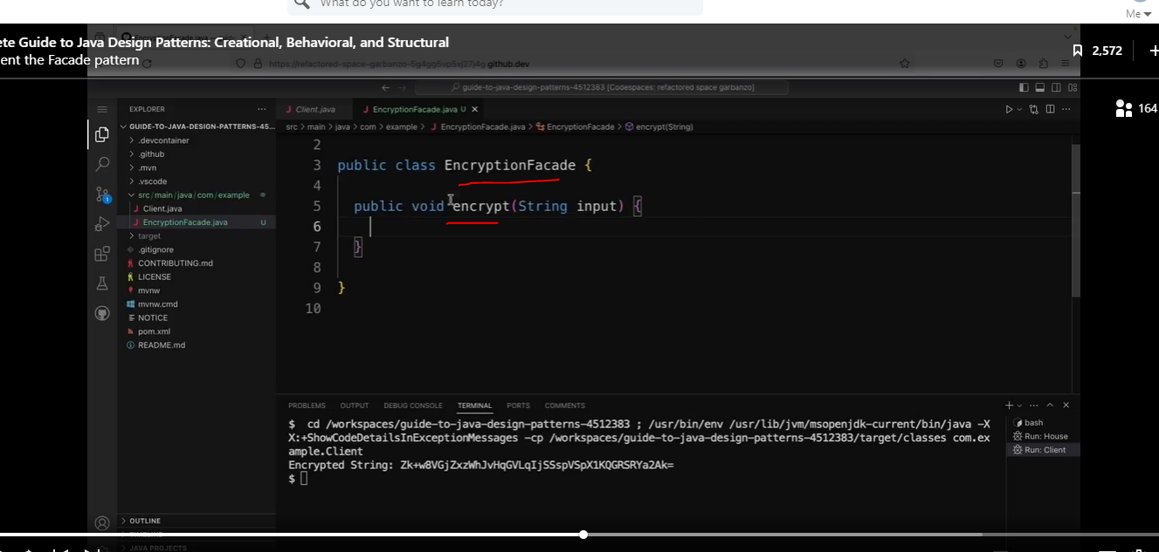

We will simply cut and paste the code from the main method in the client to the façade. 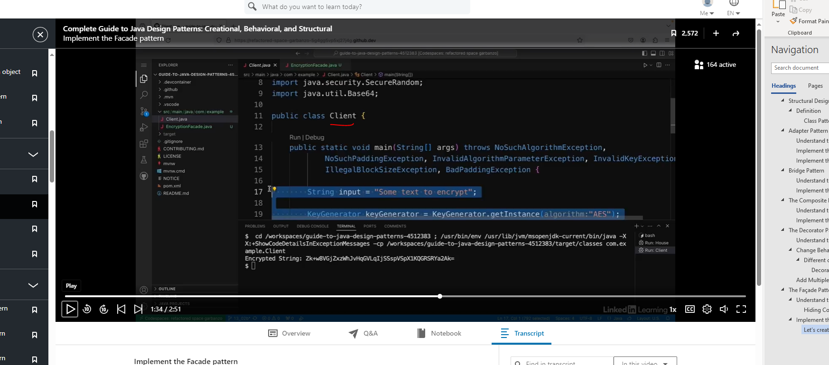

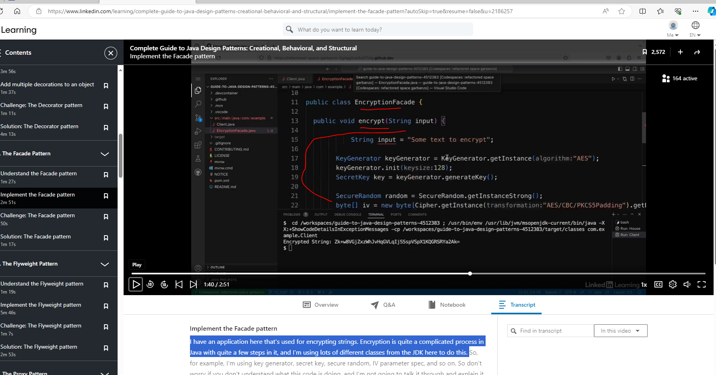

We will also cut and paste the exceptions from the client to the façade.



See client code below. I do this a lot, especially with a method called process().

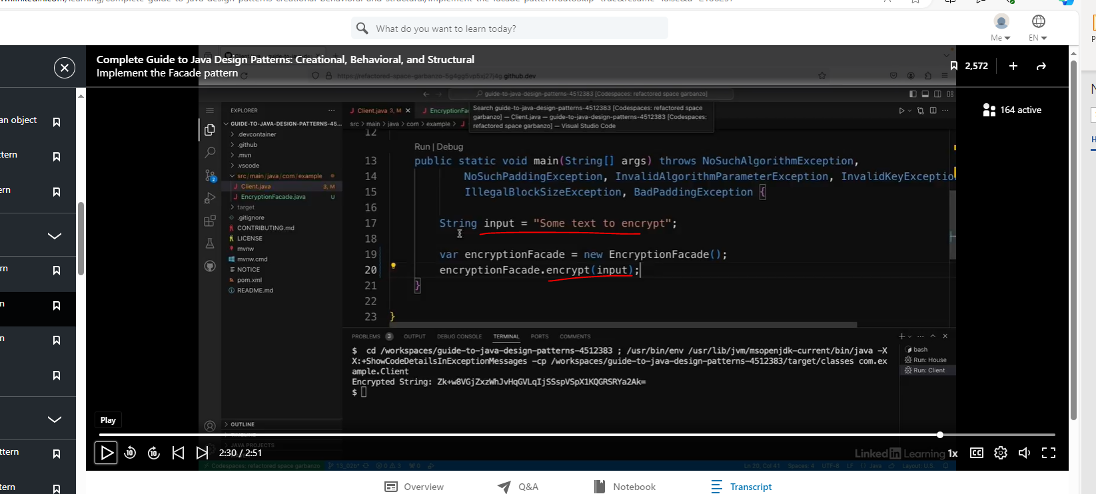

## The Flyweight Pattern

### Understand the Flyweight Pattern

#### Minimize memory usage

##### Memoization

The flyweight pattern is all about minimizing memory usage. It does this by reusing objects that have already been created rather than using new ones.

Ie.

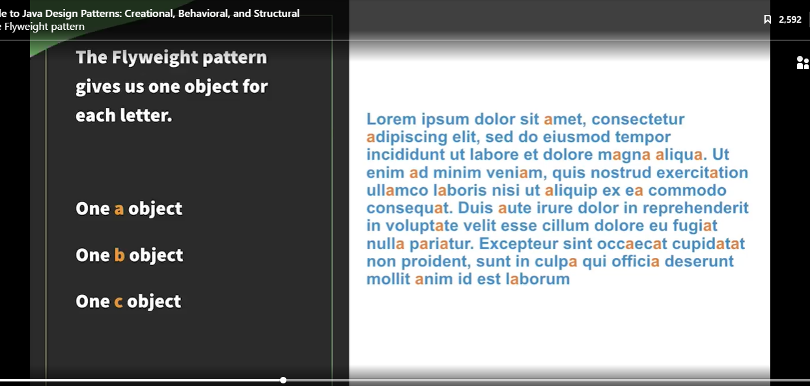

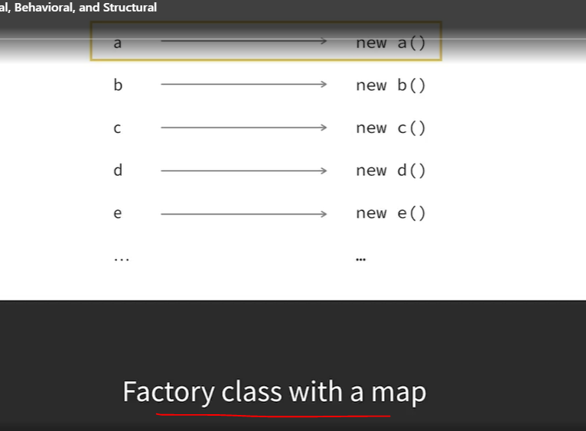

The way this is usually implemented in Java is that you have a factory class with a map, for example a HashMap. Then when someone types the letter a, it checks if there's an object with the key "a" inside the map. If not, then it creates one and puts it in the map. If there's one already there, it reuses that one. The only thing that's different about each letter a, for example, is its position in the document. So the object has states, which is immutable, for example the name of the letter.

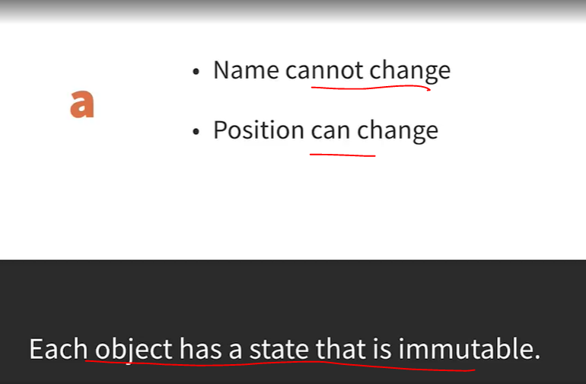

This immutable state should only be controlled through the factory. And then there should be mutable states, for example the position. This is a similar concept to a cache. The idea is that if the data is already there and can be reused, it should be. This is especially useful if it's computationally expensive to create new objects, so you should use this pattern when you want to save memory by reusing objects instead of creating new ones.

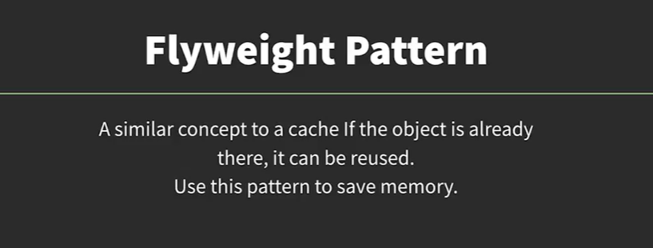

### Implement the Flyweight Pattern

See class below:

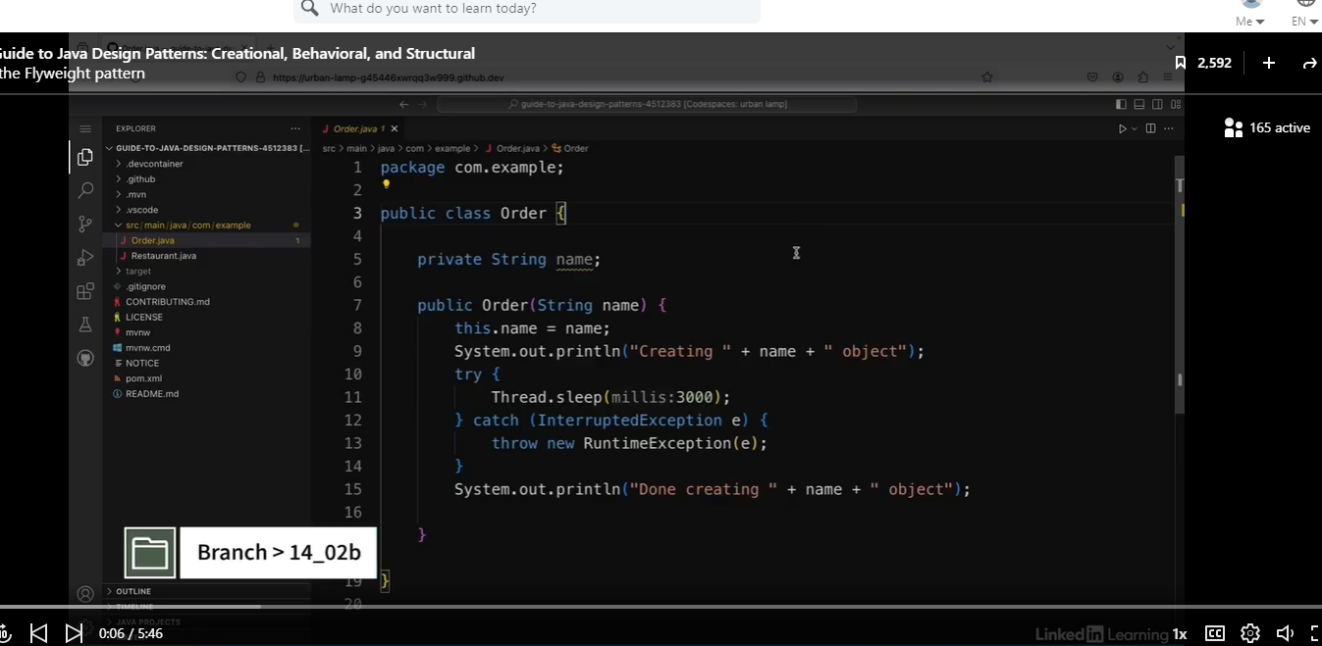

See Client code below.

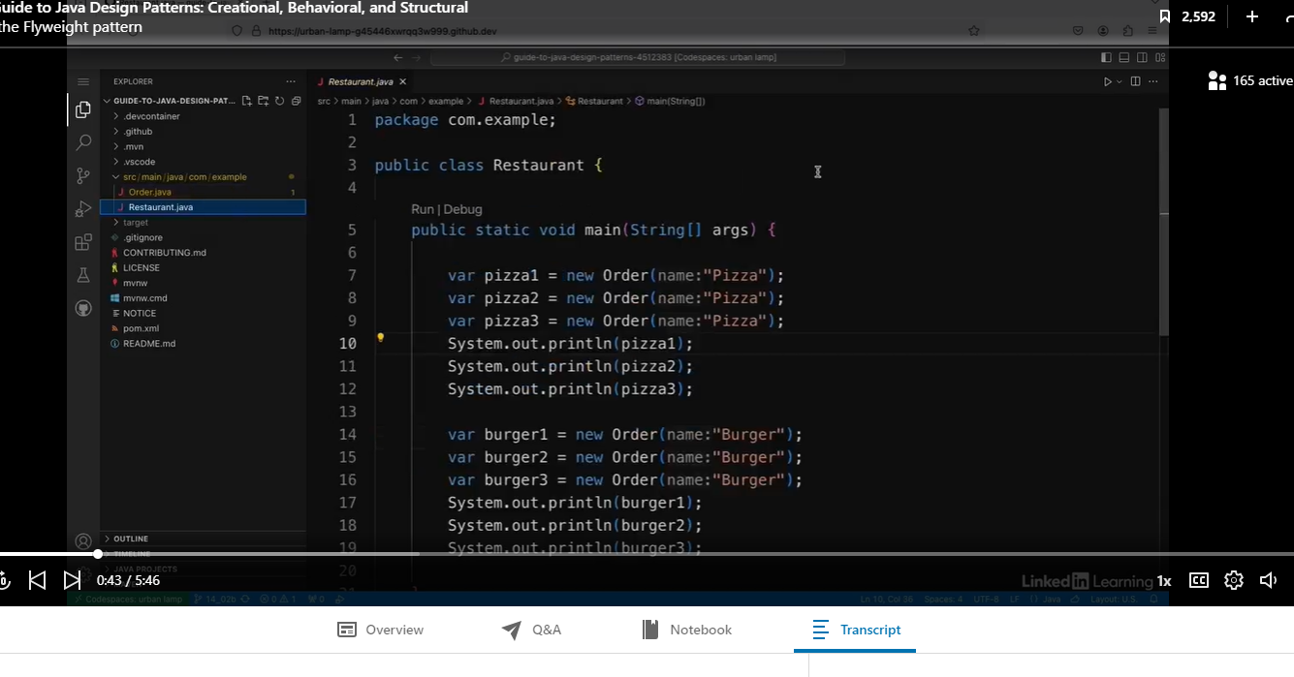

Note, the code below will be relatively slow, because the Order class on purposely has a 3 second sleep method, because we want to simulate the long processing time.

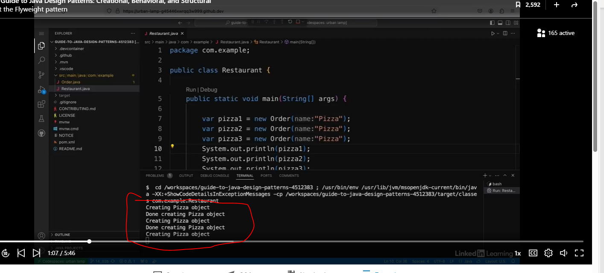

We also see different object addresses below.

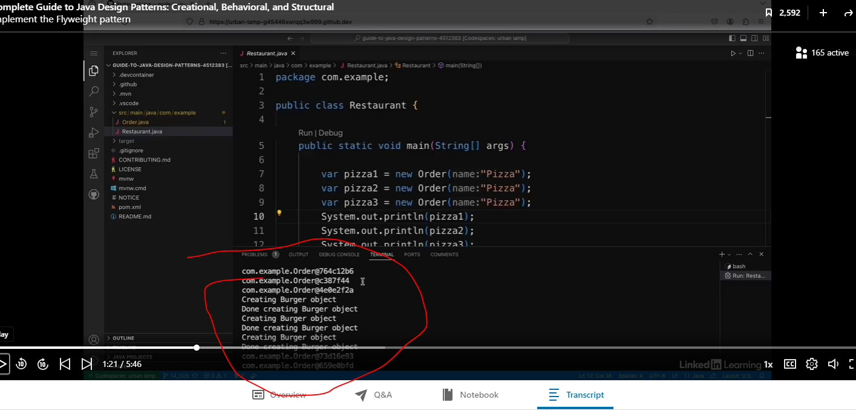

Let’s create the OrderFactory

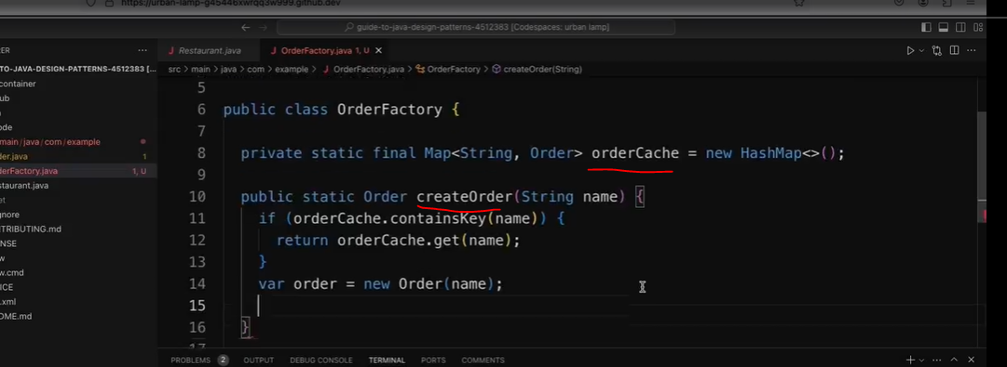

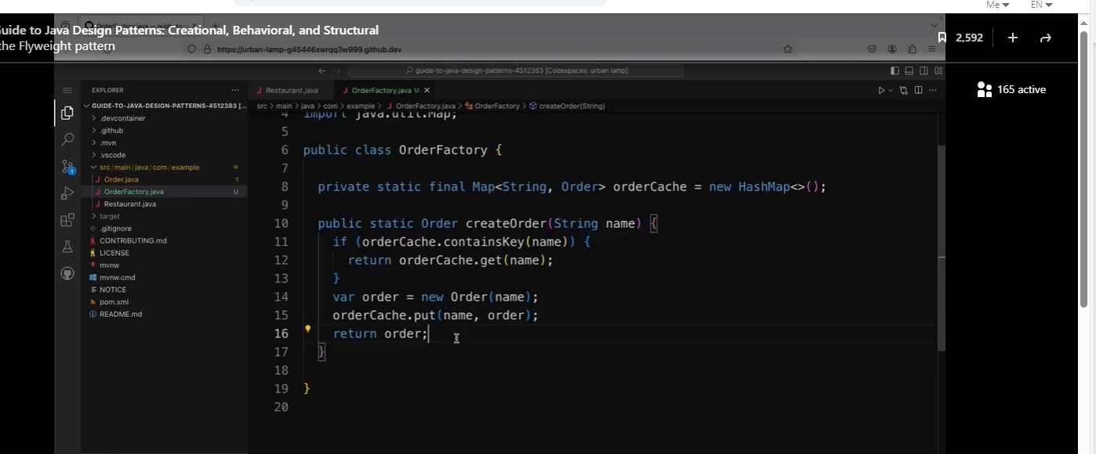

#### completeIfAbsent

Let’s refactor this even further by using completeIfAbsent. The refactoring below requires less code.

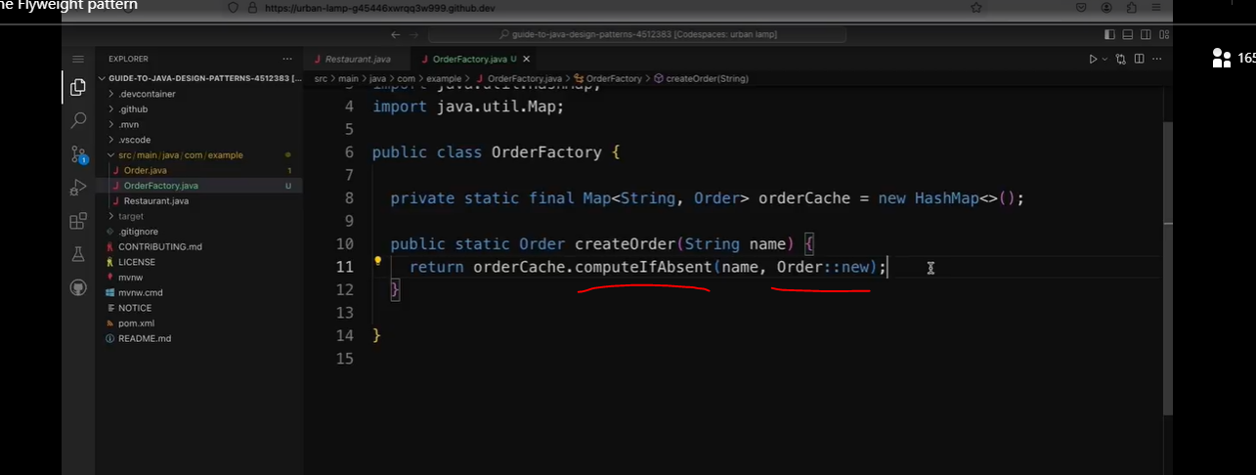

So it will check if the name is in the map, and if it is, then return the value associated with it. And if it's not, then it creates a new object, saves it in the map with that name, and returns the new object's.

Let’s refactor the Client below with our OrderFactory.

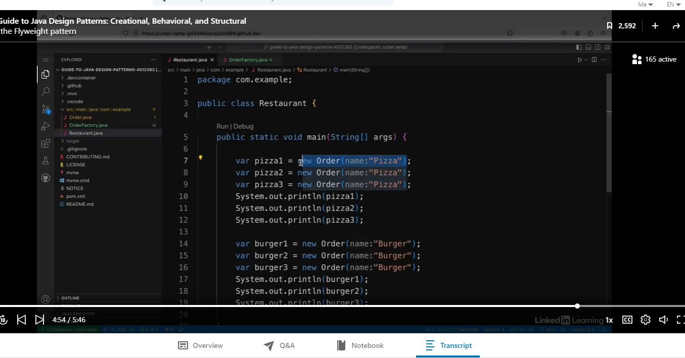

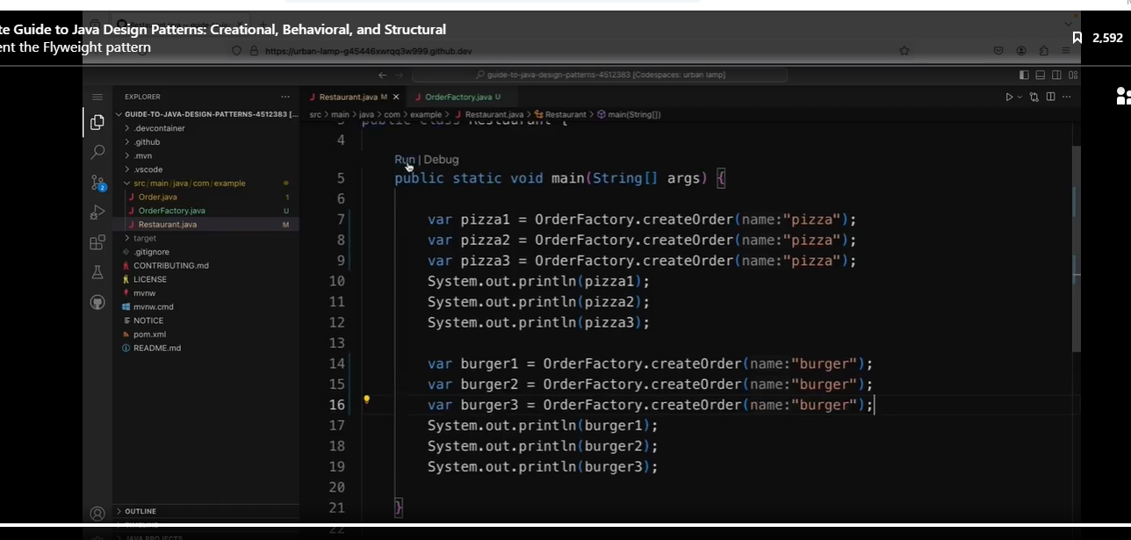

See results below:

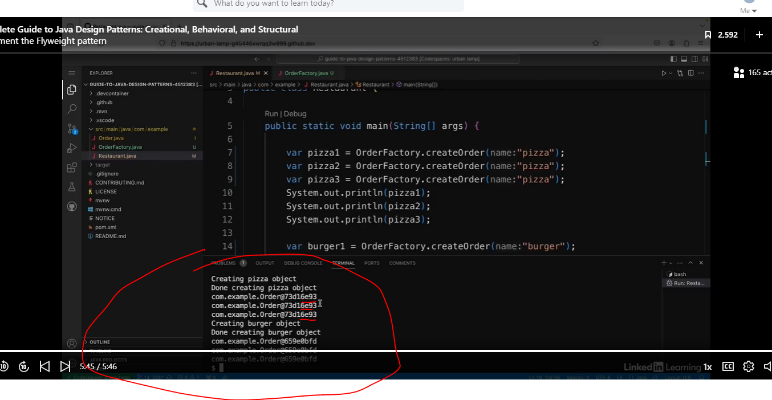

So now if I run the app again, it's a bit quicker to run this time because it only has to wait three seconds once for the pizza and once for the burger object. And I just want to show you that the object's reference is the same for each one. So instead of creating six new objects, it's just creating one pizza object and reusing it and one burger object and reusing it.

**Note, this is what you see with a lot of use cases for Functional Programming. This example uses memorization to speed up the processing of the application. The Functional Programming class in Coursera shows this a lot.

## The Proxy Pattern

### Understand the Proxy Pattern

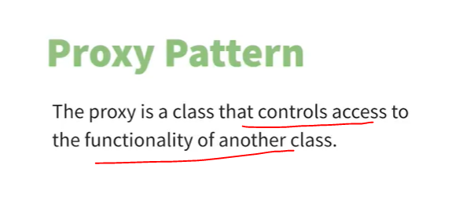

In the proxy pattern, a proxy is a class that controls access to the functionality of another class.

Example

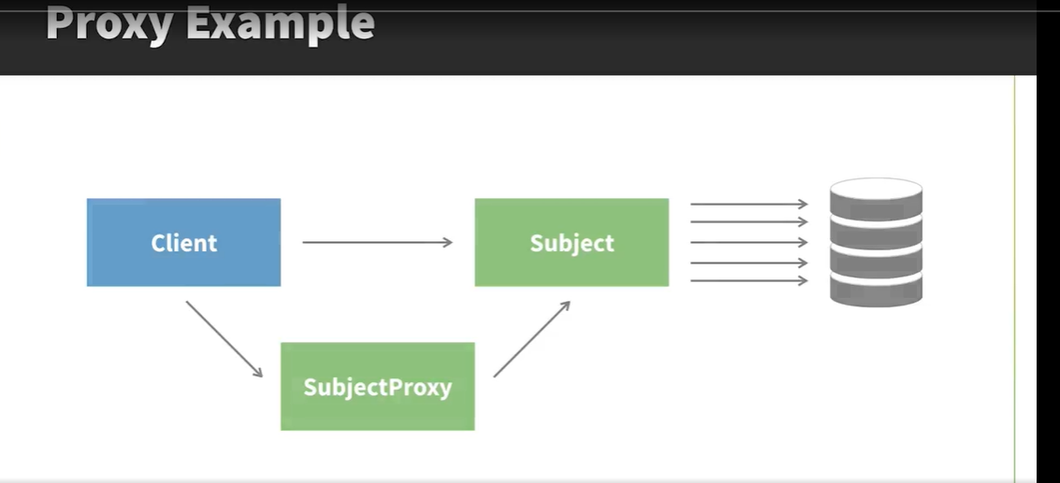

In the proxy pattern, a proxy is a class that controls access to the functionality of another class. For example, imagine that you have a class that does some expensive setup when you create a new instance of it. When describing this pattern, this class is sometimes referred to as the subject. So let's say, for example, that the first time the subject is used, it has lots of expensive calls to a database, and then later it does something with the data. This code might be in a third-party library, so you might not have access to it. In this case, you only want the expensive setup to happen once, the first time the object is created. After that, you just want to do the part where it processes the data. You don't really want the classes that call this code to have to implement the logic about only doing this setup once. So in this case, you'd have a proxy object in between, and that controls access to the class with the expensive setup. Then the client just calls the proxy.

#### Use Case

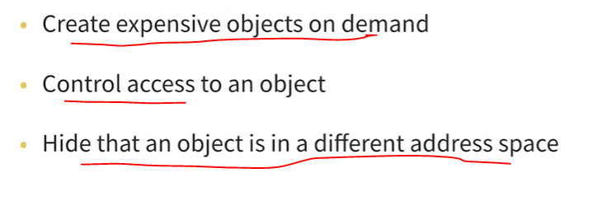

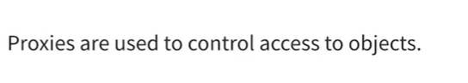

### Recognize when to use the Proxy Pattern

See class below:

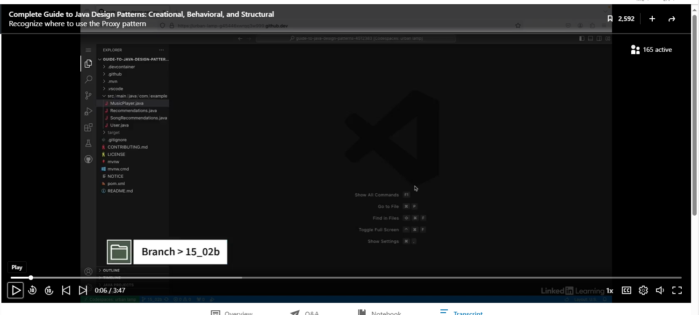

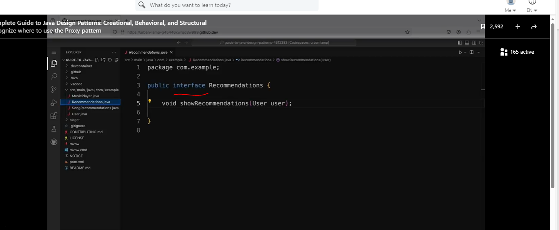

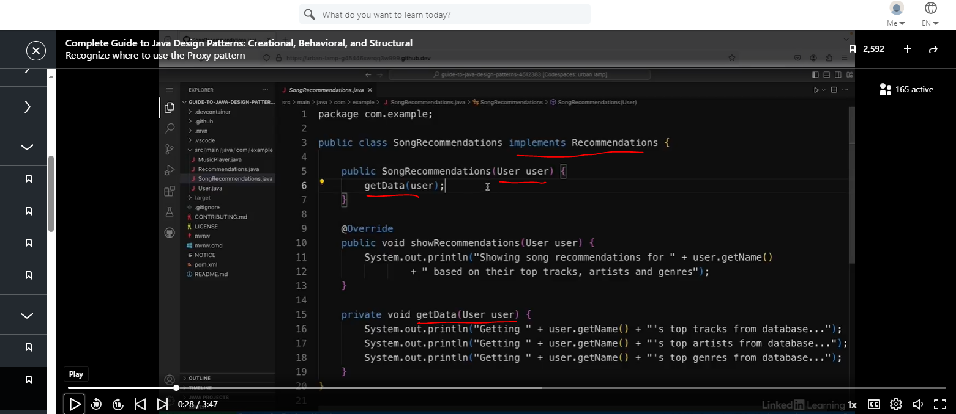

So this getData method does three calls to the database; one to get the user's top tracks, one to get the user's top artists, and one to get the user's top genres. So this will happen every time the constructor is called.

And then there's a public method called showRecommendations, which overrides the method from the interface. And this just prints out a message saying showing song recommendations for the user's name and then based on their top tracks, artists, and genres. And the user class is a simple class with a string field called name, and that's set by passing it into the constructor.

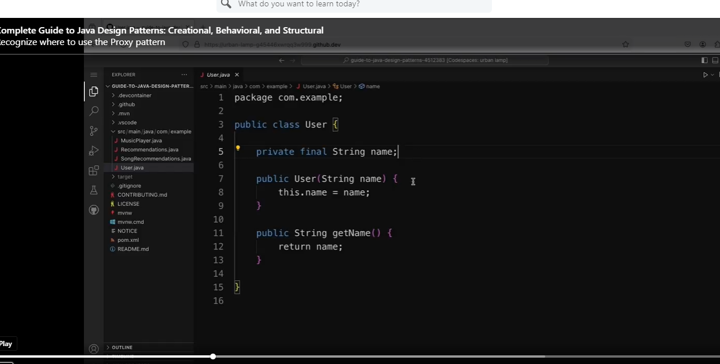

Client Code

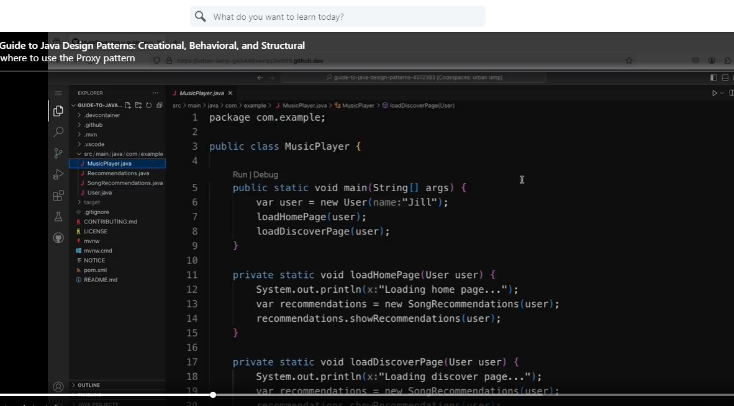

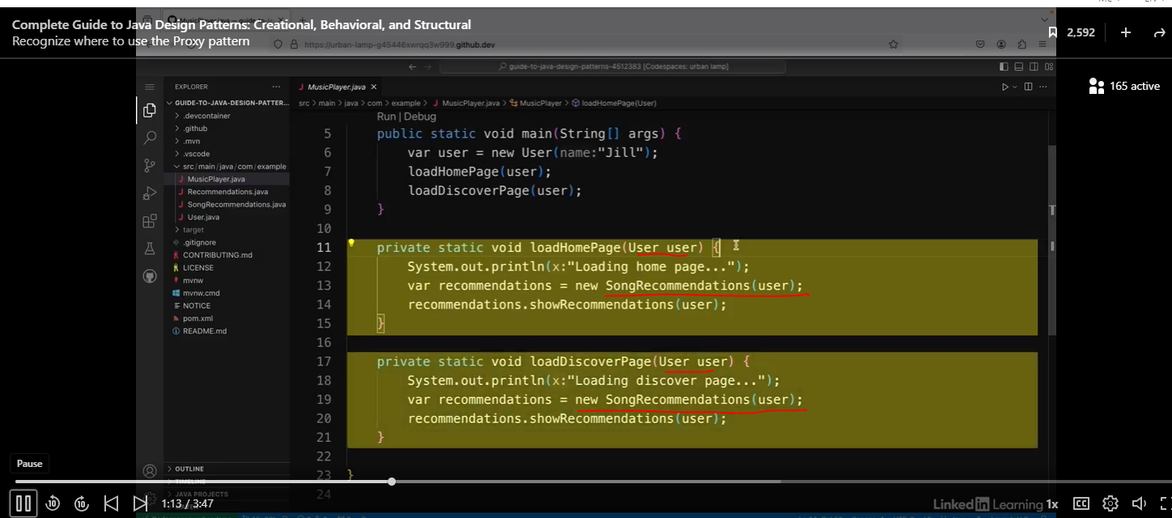

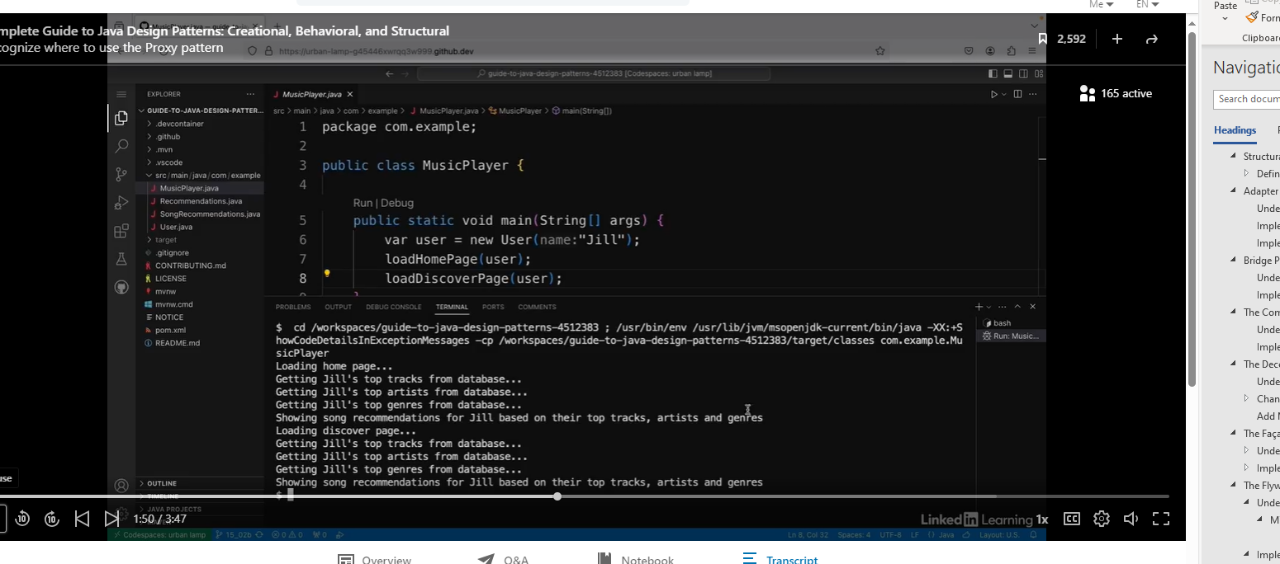

So if I run this, I can see it loads the home page then it does the three calls to the database and then it shows the recommendations for Jill. And then again when she goes to the discover page, it does the three calls to the database again and again it shows the song recommendations for Jill based on their top tracks, artists, and genres. So I can see that when both the pages are loaded, it does the expensive operation of fetching all the data from the database both times.

See the refactorings below:

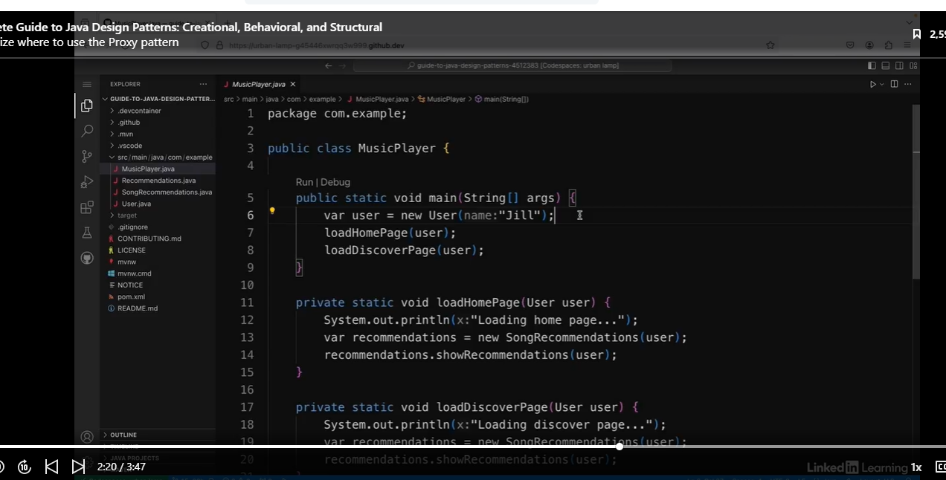

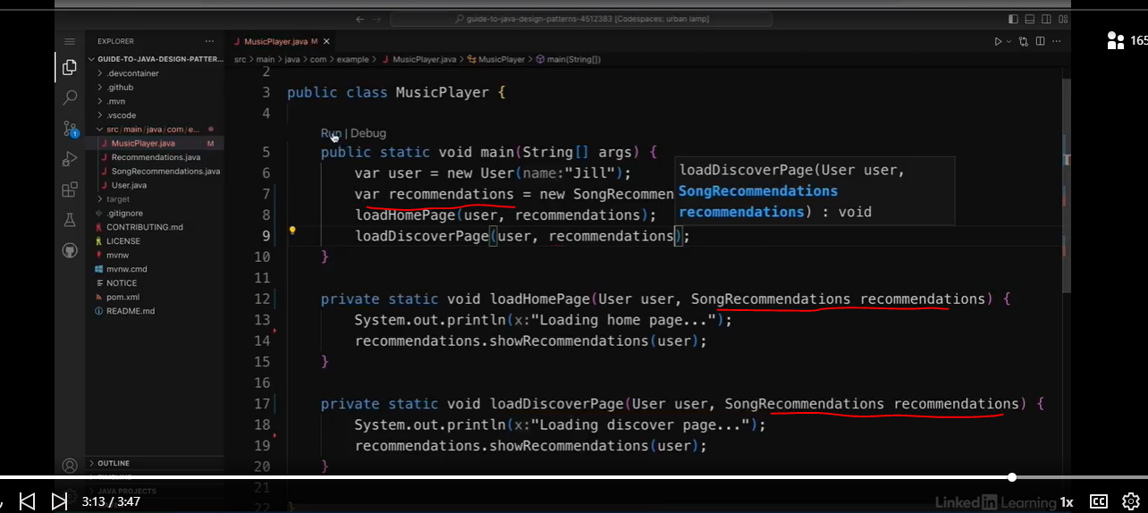

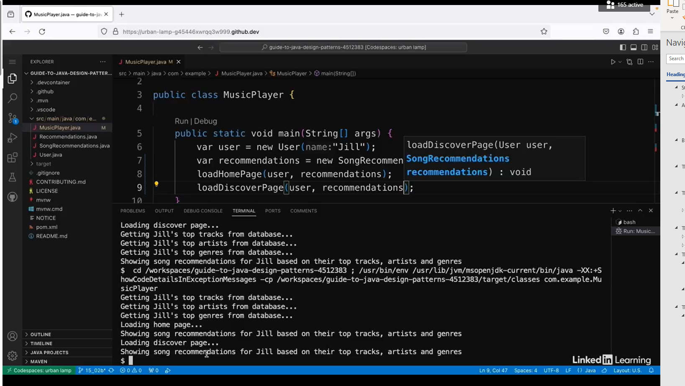

So if I run this again. Now I can see that this time it does the three calls to the database only once, and then it loads the home page and shows the recommendations, and then it loads the discover page and shows the recommendations. So this is a bit better. But then what if the user never opens the home page or the discover page? They might open the music player on some other page, like a playlist page, for example. And in that case, I've done the expensive calls for no reason at all. So the solution to this problem is to use a proxy object. So this is a use case where the proxy pattern can be used to help optimize an application.

### Use a Proxy To Create Objects on Demand

I'm going to use the proxy pattern to optimize my app that gives suggestions to users based on the songs they've listened to.

See Code below:

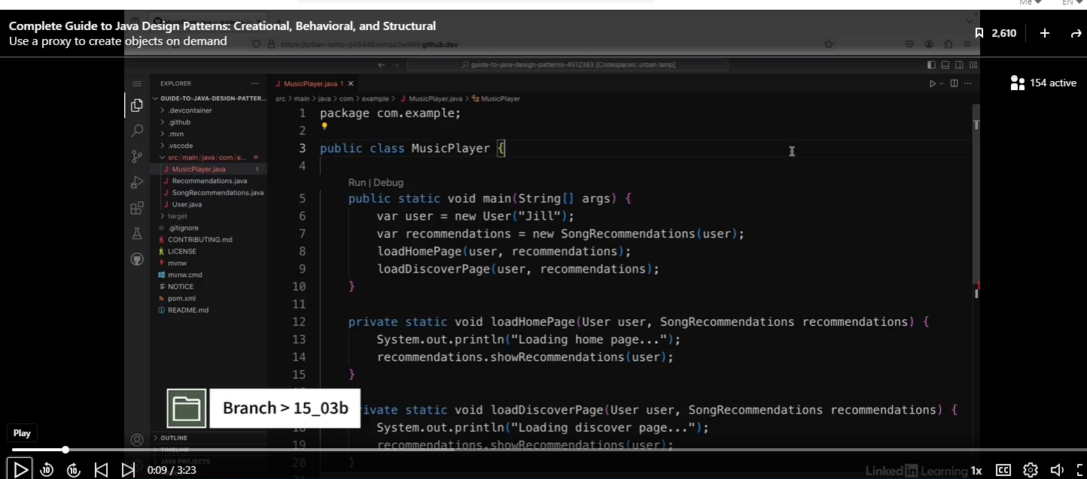

Let’s create the class Recommendation Proxy that implements the Recommendations interface.

Note: Should we use Optional instead of doing a null check?

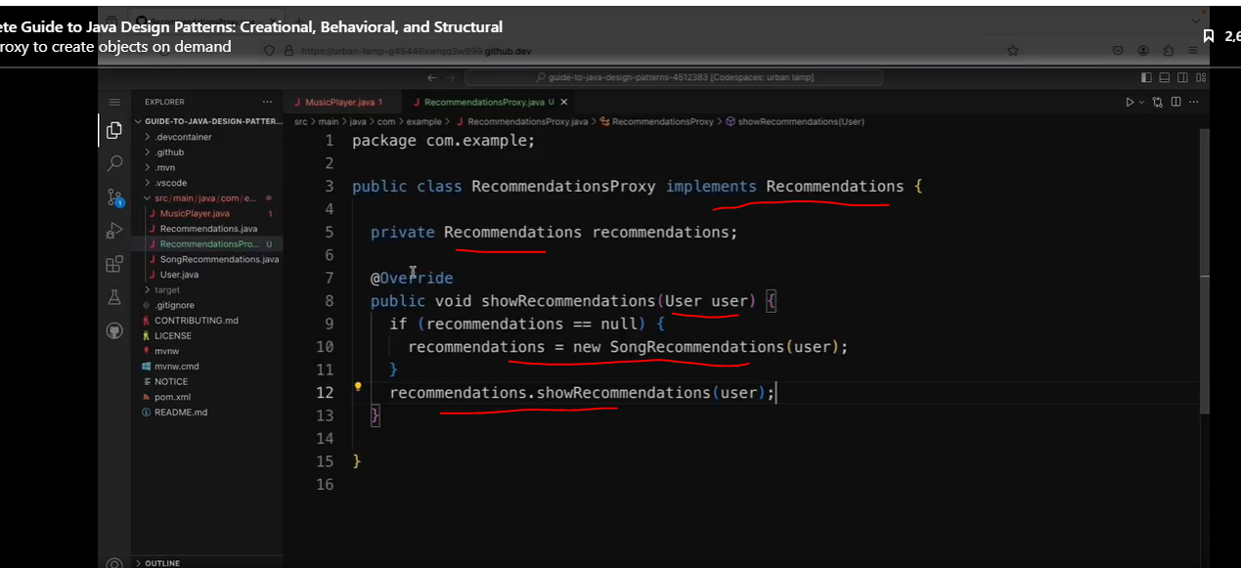

Let’s go back to our client class.

We will add a static member, which is our RecommendationsProxy that we just creatd.

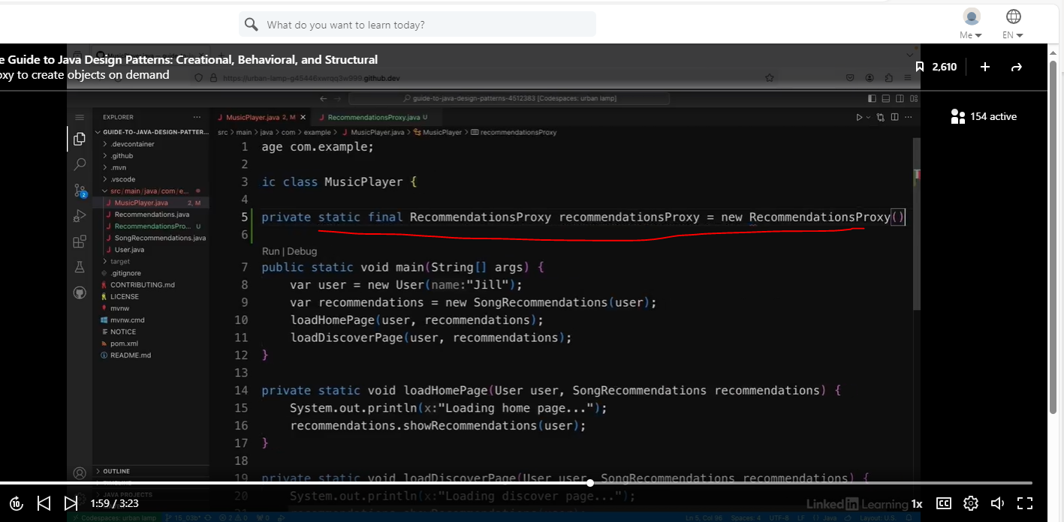

So we will use the proxy in the two methods below:

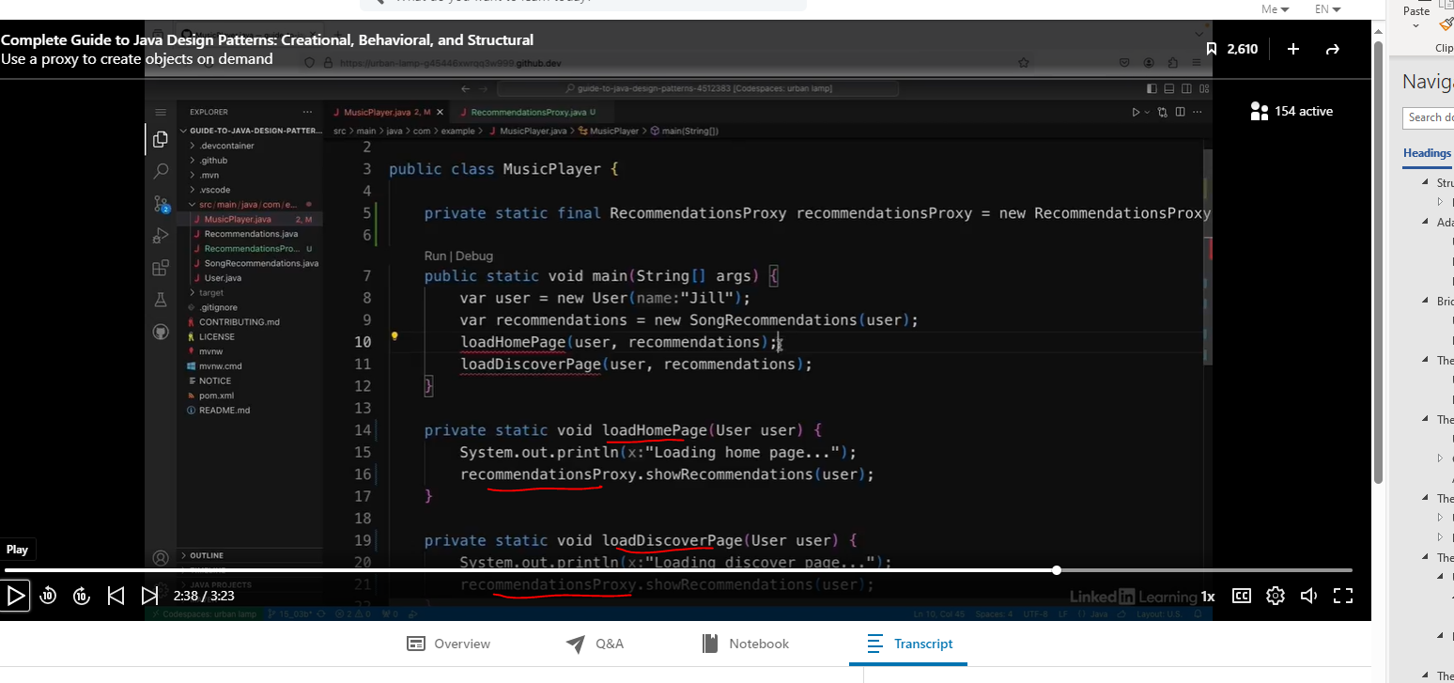

Then we will simplify our main method.

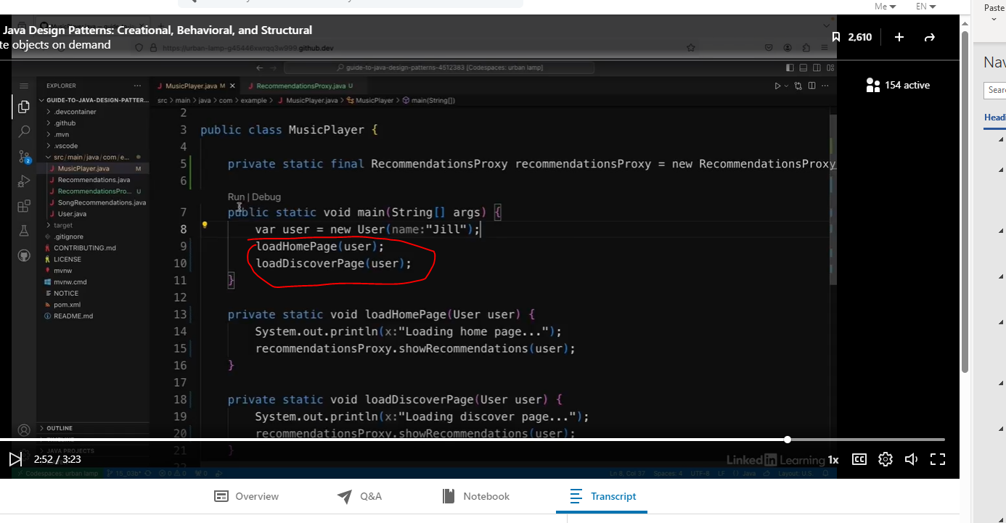

Let’s run the code below:

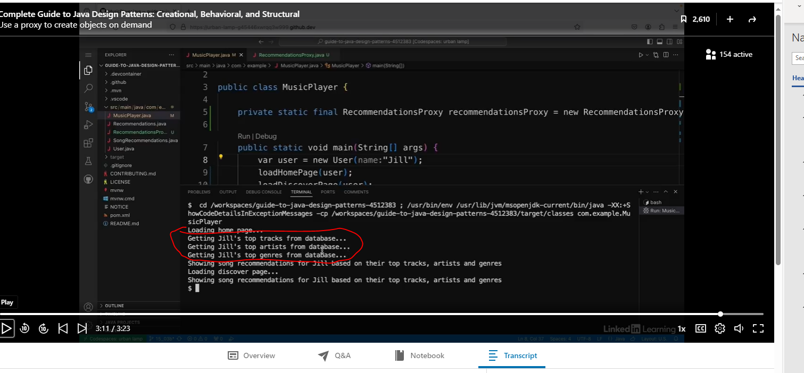

So it only does the expensive calls to the database once and that's only after it loads the home page. So it knows it's definitely going to need that data. So this is one use for a proxy, making sure that expensive object initialization is only done on demand.

### Use a Proxy to Control Access

In my music app, I'm using the proxy pattern to optimize the expensive initialization of objects that show song recommendations to a user based on what they've listened to before. But let's say that I only want the song recommendations feature to be available to premium users.

See code below:

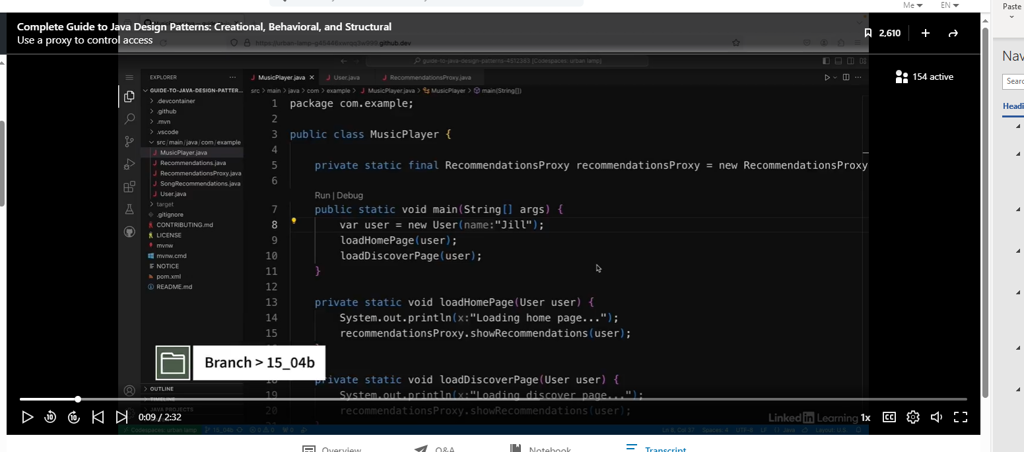

Let’s update the User class below:

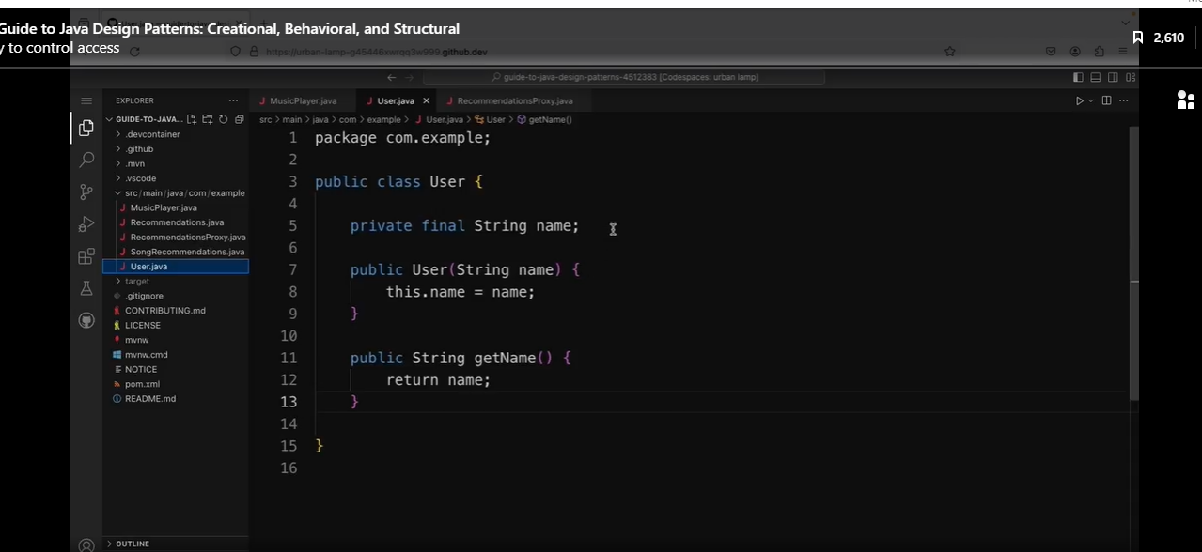

We will add the field, isPremium.

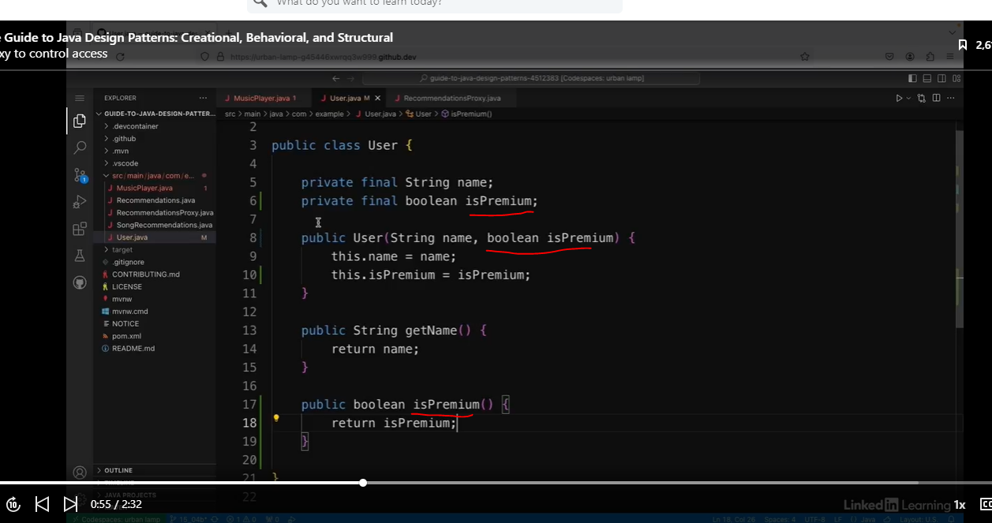

Let’s fix the client code below:

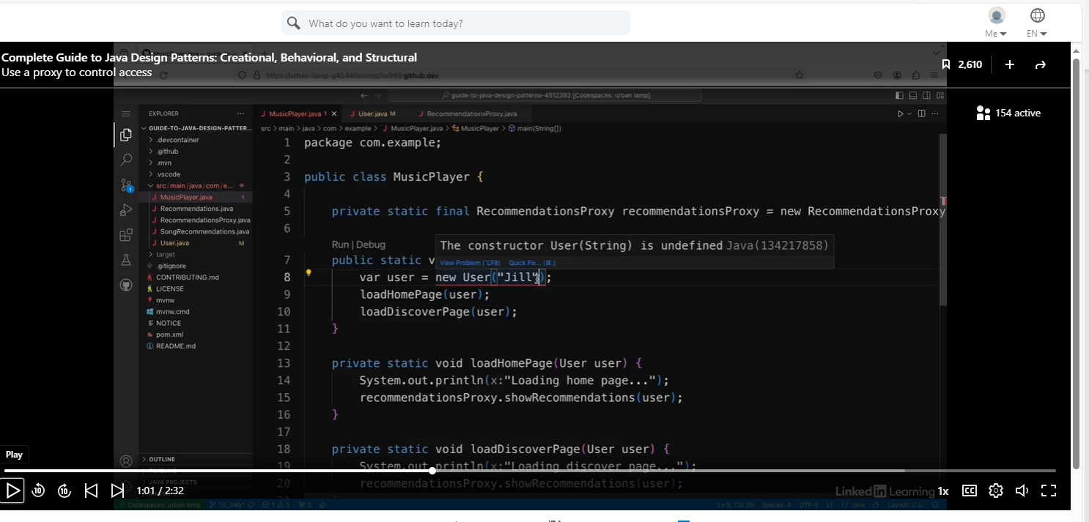

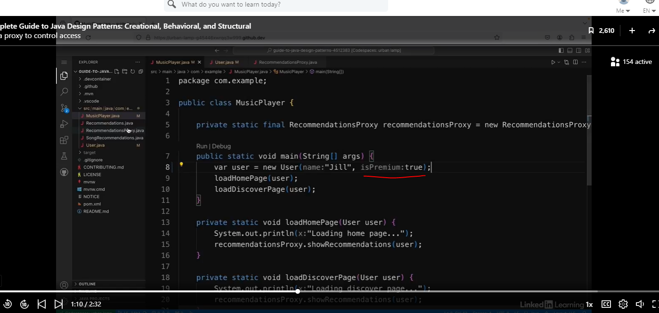

We also need to update our proxy class.

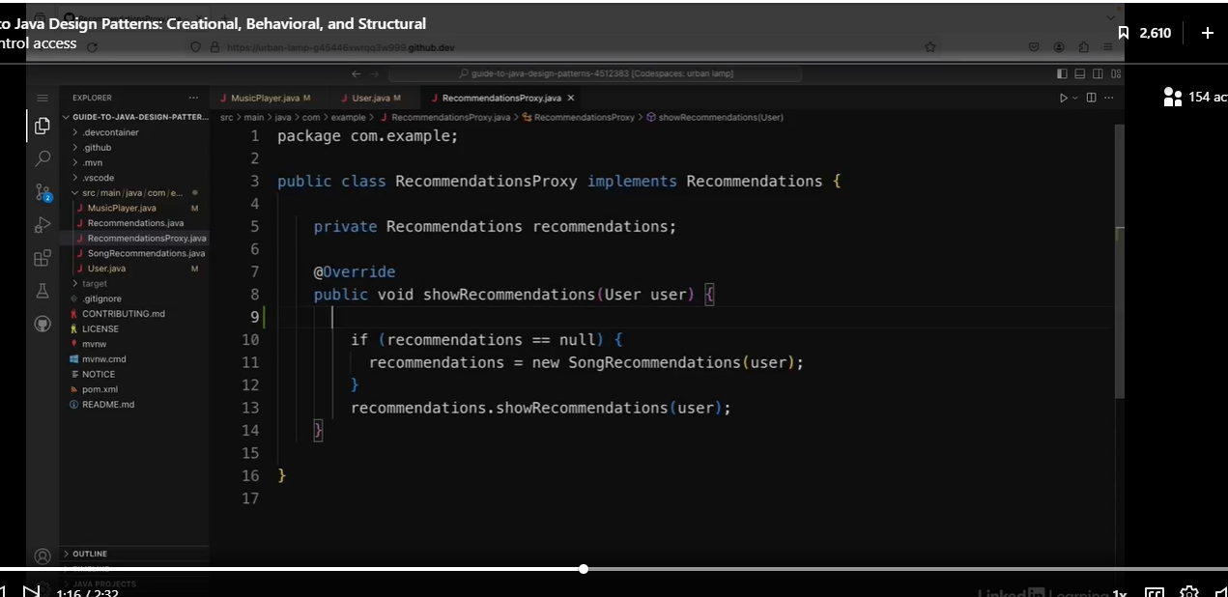

Eewww. A nested if/else.

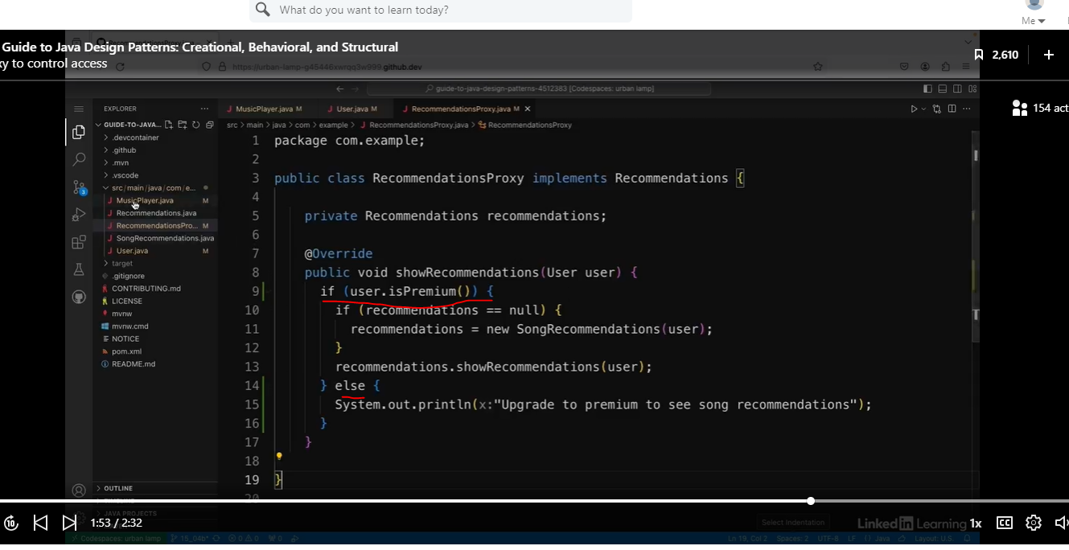

See output below when we run this code:

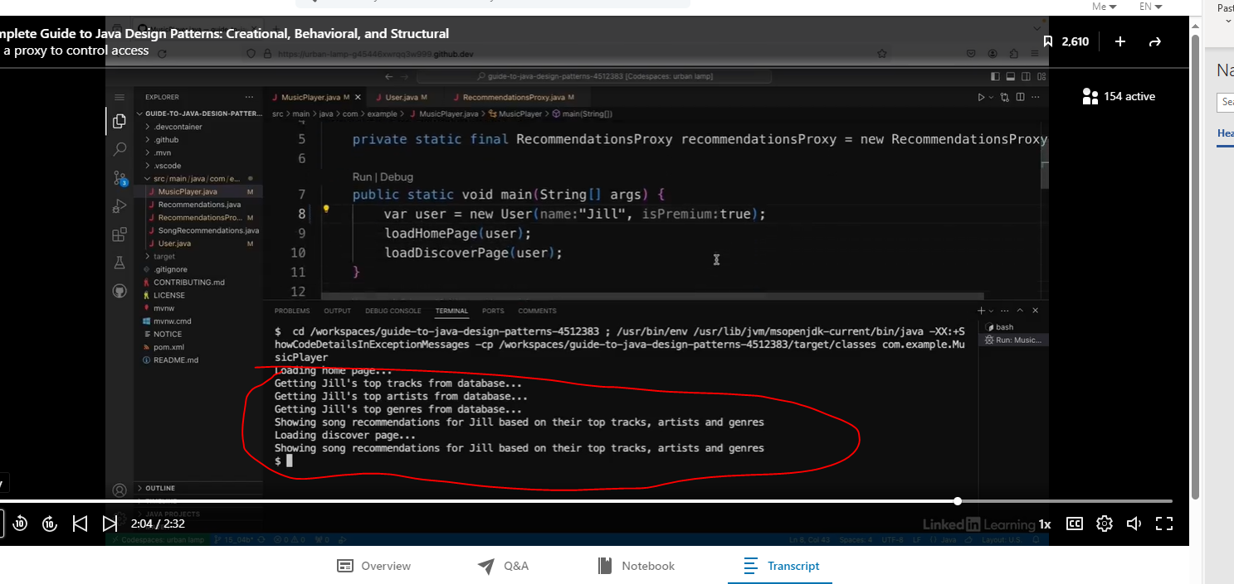

Now we see the upgrade to premium results.

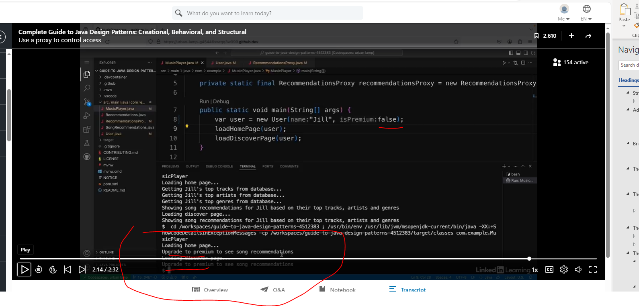

So now if I go back to the Music Player app again and I run the app again, I can see that it still prints out Jill's recommendations as usual, as before, and that's because she is a premium user. So if I change isPremium to false and run the app again. This time I can see it says loading home page and then upgrade to premium to see song recommendations and then loading discover page and then upgrade to premium to see song recommendations. So this is another use case for using a proxy, controlling access to the functionality of another object. And as we can see, the proxy can be used to do multiple checks before performing operations.